

**S.N.B.P SENIOR COLLAGE**

**YERWADA ,PUNE.**

***CERTIFICATE***

**This is to certify that the Project entitled**

**“ Online Food Ordering System ”**

**Has been completed successfully by**

**Akshata Shirwale**

**&**

**Twinkle Bansal**

**Towards the partial fulfilment of the Bachelor of Computer Science in Science Department from University of Pune, for the Academic Year of 2021 – 2022.**

**External Examiner H.O.D**

**Science Department**

**Internal Examiner Project Guide**

A

PROJECT ON

Online food ordering system

**Towards the partial fulfilment of the Bachelor of Computer Science in Science Department from University of Pune, for the Academic Year of 2021 – 2022.**

**BY**

**AKSHATA SHIRWALE**

**&**

**TWINKLE BANSAL**

**GUIDED BY: PROF. RAJESHRI**

**GAIKWAD**

|  |  |  |
| --- | --- | --- |
| **SR.NO** | **TITLE** | **PAGE.NO** |
|  | INTRODUCTION | 5 |
|  | OBJECTIVES | 6 |
|  | SCOPE | 8 |
|  | FEASIBILITY STUDY | 10 |
|  | HARDWARE & SOFTWARE REQUIREMENT | 11 |
|  | ENTITY REALTIONSHIP (E-R) DIAGRAM | 12 |
|  | UML - DIAGRAMS | 13 |
|  | DATA FLOW DAIGRAM (DFD) | 17 |
|  | INPUT /OUTPUT SCREEN | 20 |
|  | REPORTS | 64 |
|  | LIMITATIONS | 71 |
|  | CONCLUSION | 72 |
|  | BIBILOGRAPHY | 73 |

**INDEX**

**ACNOWLEDGEMENT**

**We would like to express our profound thanks to all those who helped in making this project a reality. Much needed moral support and encouragement was provided on numerous occasions by all teachers and fellow students.**

**We are thankful to our Head of the Department. We are also especially grateful to our teacher and project guide *Mrs. Rajeshri Gaikwad* for his time to time, much needed, valuable guidance. she has been available to help us whenever required. she has been our guiding star, guiding us through the right direction to make this project a success. Without his full support and cheerful encouragement we would have not been able to complete the project in time. We are sincerely thankful to him.**

**Last but not the least we would like to thank our fellow student for providing their support to us in different ways.**

**INTRODUCTION**

**In a modern generation Online food ordering is a mobility of food delivery or takeout from a local restaurant or food cooperative. Now days the rapid growth in the use of internet and the technologies associated with it, the several opportunities are coming up on the web or mobile application. This is made possible through the use of electronic payment system. The payment can be done through the customer’s credit card, debit card. It is possible for everyone to order any goods from anywhere the internet and have the goods delivered at his/her home. All types made be internet le transaction ads to the economic of digital cash, the necessary tool for this process telecommunication with customers.**

**The system will become an important tools use for restaurant to improve the management aspect by use of computer system to connected each and every food ordering transaction instead of data record on it. In addition, it can also provide efficiency for the restaurant by reducing time consuming, minimize human errors or delivery and providing good quality and service to customers. In terms of the integrity and availability of the system provided, it can be concluded that this system is a suitable solution.**

**OBJECTIVE**

**The main objective of the Project on Online Food Ordering System is to manage the details of Food, Item Category, Shopping Cart, Customer, Order. It manages all the information about Food, Delivery Address, Order, Food. The project is totally built at administrative end and thus only the administrator is guaranteed the access. The purpose of the project is to build an application program to reduce the manual work for managing the Food, Item Category, Delivery Address, Shopping Cart. It tracks all the details about the Shopping Cart, Customer, Order.**

**The study has the following specific objectives :-**

* **To develop a system that will surely satisfied the customer service.**
* **To design a system able to accommodate huge amount of orders at a time.**
* **To evaluate its performance and acceptability in terms of security, user-friendliness, accuracy and reliability**
* **To improve the communication between the client and the server and minimize the time of ordering.**

**THE EXISTING SYSTEM**

***DESCRIPTION OF EXISTING SYSTEM :-***

* **Many of customer’s placed the order for their foods for their ongoing events .**
* **It is very difficult to maintain the record each and every customer’s, customers transactions manually by paper.**
* **The new System Overcome this problem, by computerizing transactions and providing easy backup of the data time to time.**

***DRAWBACKS OF THE EXISTING SYSTEM*** :-

* **Data security .**
* **Risk of losing customer’s data .**
* **Chances of a technical problem in the system .**
* **Mismatch data of orders, customers and drivers .**
* **Difficulty in choosing the right developer to develop a customized system .**

**• More man power.**

**• Time consuming.**

**• Consumes large volume of pare work.**

**• Needs manual calculations.**

**THE PROPOSED SYSTEM**

***SCOPE OF THE PROPOSED SYSTEM :-***

**The proposed system is designed to overcome the limitations of existing system. By computerizing the system, human errors will be rectified to the maximum thereby enhancing the efficiency of the system. The obsolete system of manual entry and calculation can be removed and this method could be adopted to bring into action a more efficient system.** **It may help collecting perfect management in details. In a very short time, the collection will be obvious, simple and sensible. It also helps in current all works relative to Online Food Ordering System. It will be also reduced the cost of collecting the management & collection procedure will go on smoothly .**

**• In computer system the person has to fill the various forms & number of copies of the forms can be easily generated at a time.**

**• In computer system, it is not necessary to create the manifest but we can directly print it, which saves our time.**

**• To utilize resources in an efficient manner by increasing their productivity through automation.**

**• The system generates types of information that can be used for various purposes.**

**• It satisfy the user requirement**

**• Be easy to understand by the user and operator**

**• Be easy to operate**

**• Have a good user interface**

**• Be expandable**

***BENEFITS OF THE PROPOSED SYSTEM :-***

**The aim of proposed system is to develop a system of improved facilities. The proposed system can overcome all the limitations of the existing system.**

* **Fully automated and hence reduces human errors and investments.**
* **Customer’s queue is minimized because of the automated system.**
* **Security to the data is given by providing password at various stages.**
* **Flexibility in technology and Implementation.**
* **Easier to maintain, Edit and Update records.**
* **The system provides proper security and reduces the manual work.**
* **Security of data.**
* **Ensure data accuracy’s.**
* **Proper control of the higher officials.**
* **Minimize manual data entry.**
* **Minimum time needed for the various processing.**
* **Greater efficiency.**
* **Better service.**
* **User friendliness and interactive.**
* **Minimum time required.**

**FEASIBILITY STUDY :-**

**After doing the project Online Food Ordering System, study and analyzing all the existing or required functionalities of the system, the next task is to do the feasibility study for the project. All projects are feasible - given unlimited resources and infinite time. Feasibility study includes consideration of all the possible ways to provide a solution to the given problem. The proposed solution should satisfy all the user requirements and should be flexible enough so that future changes can be easily done based on the future upcoming requirements.**

# **A . Economical Feasibility :-**

**This is a very important aspect to be considered while developing a project. We decided the technology based on minimum possible cost factor. All hardware and software cost has to be borne by the organization. Overall, we have estimated that the benefits the organization is going to receive from the proposed system will surely overcome the initial costs and the later on running cost for system.**

**B . Technical Feasibility :-**

**This included the study of function, performance and constraints that may affect the ability to achieve an acceptable system. For this feasibility study, we studied complete functionality to be provided in the system, as described in the System Requirement Specification (SRS), and checked if everything was possible using different type of frontend and backend plaformst.**

**C. Operational Feasibility :-**

**No doubt the proposed system is fully GUI based that is very user friendly and all inputs to be taken all self-explanatory even to a layman. Besides, a proper training has been conducted to let know the essence of the system to the users so that they feel comfortable with new system. As far our study is concerned the clients are comfortable and happy as the system has cut down their loads and doing.**

**HARDWARE AND SOFTWARE**

**REQUIREMENT**

***Hardware requirements :-***

|  |  |
| --- | --- |
| **Description** | **Required** |
| **Processor** | **Pentium III 630MHz** |
| **Ram** | **128 MB** |
| **Hard Disk** | **20 GB** |
| **Moniter** | **15 inches Colour Moniter** |
| **Keyboard** | **122 Keys** |
| **Operating System** | **64 Bit** |

***Software requirements :-***

|  |  |
| --- | --- |
| **Server** | **Apache 2.4.5** |
| **Front-end** | **Html , Css , Bootstrap , Ajax, Jquery** |
| **Back-end** | **PHP 8.4.1, PostgreSQL 5.5.32**  **( using phpmyadmin 5.1.3 )** |
| **Integrated Development Environment (IDE)** | **Netbeans 7.3.1** |
| **Platform** | **Windows 10** |

**Erd-online food ordering system :-**

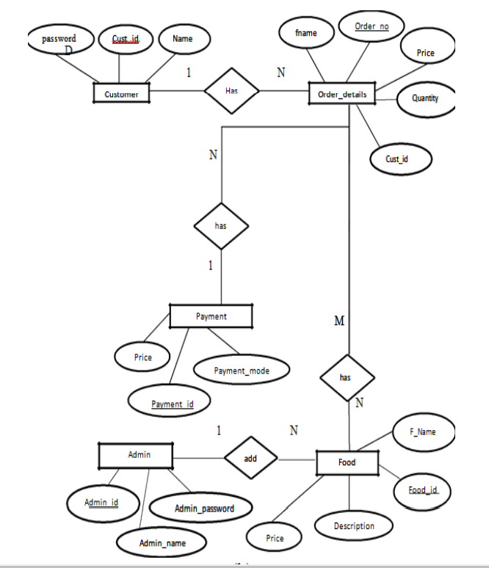

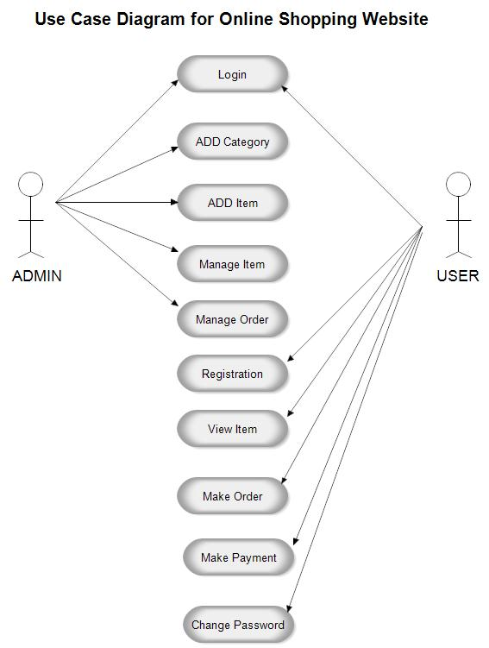**Usecase diagram :-**

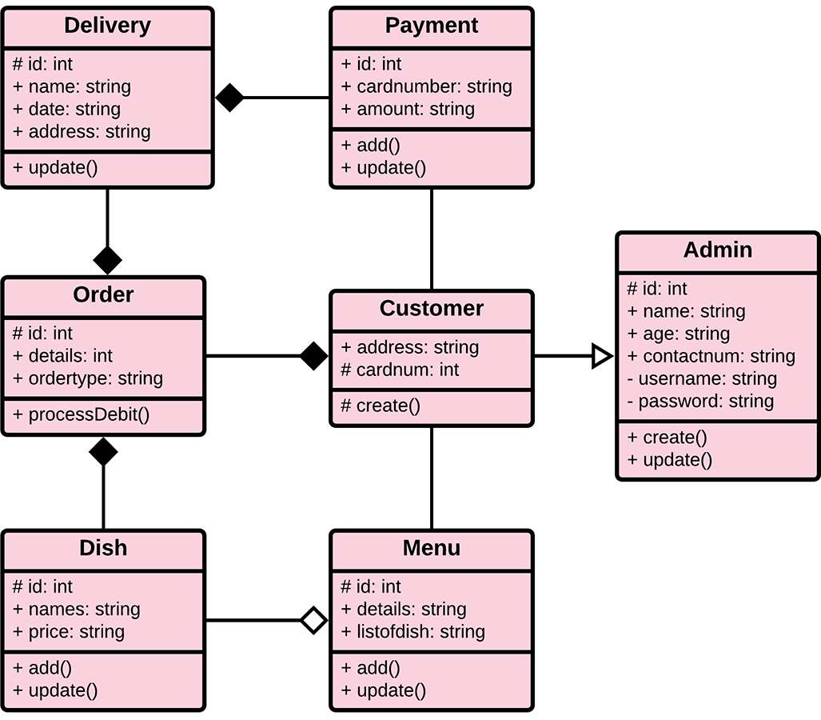**Class diagram :-**

**Sequance diagram :-**

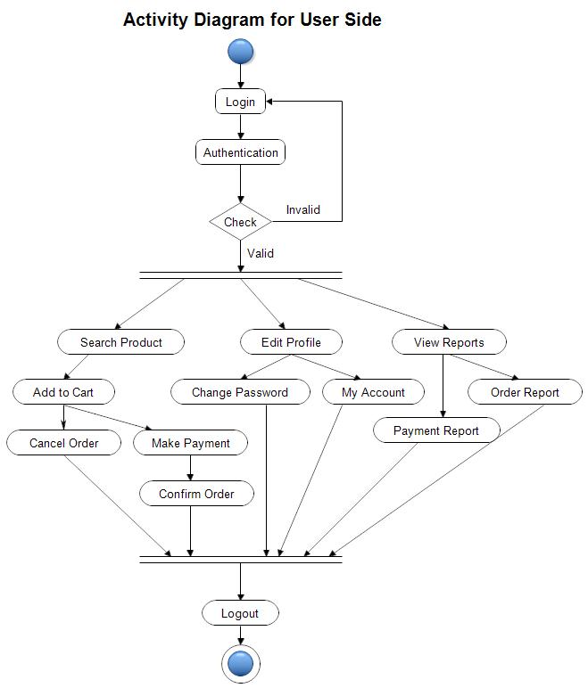**Activity diagram :-**

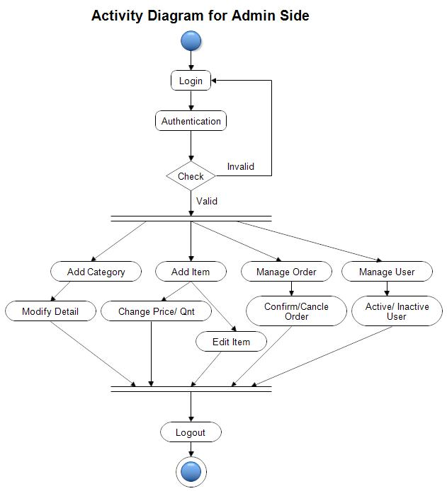

**Context Level DFD**

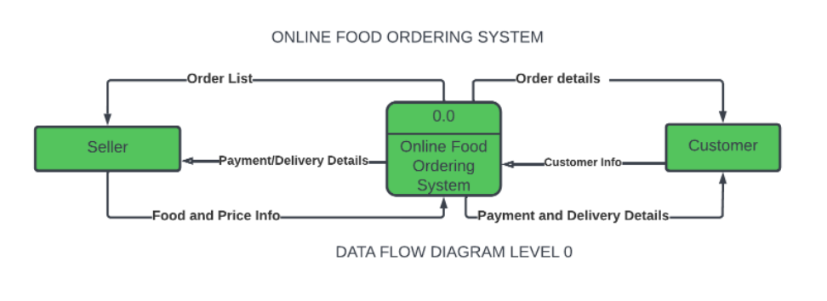

**First Level DFD (1st)**

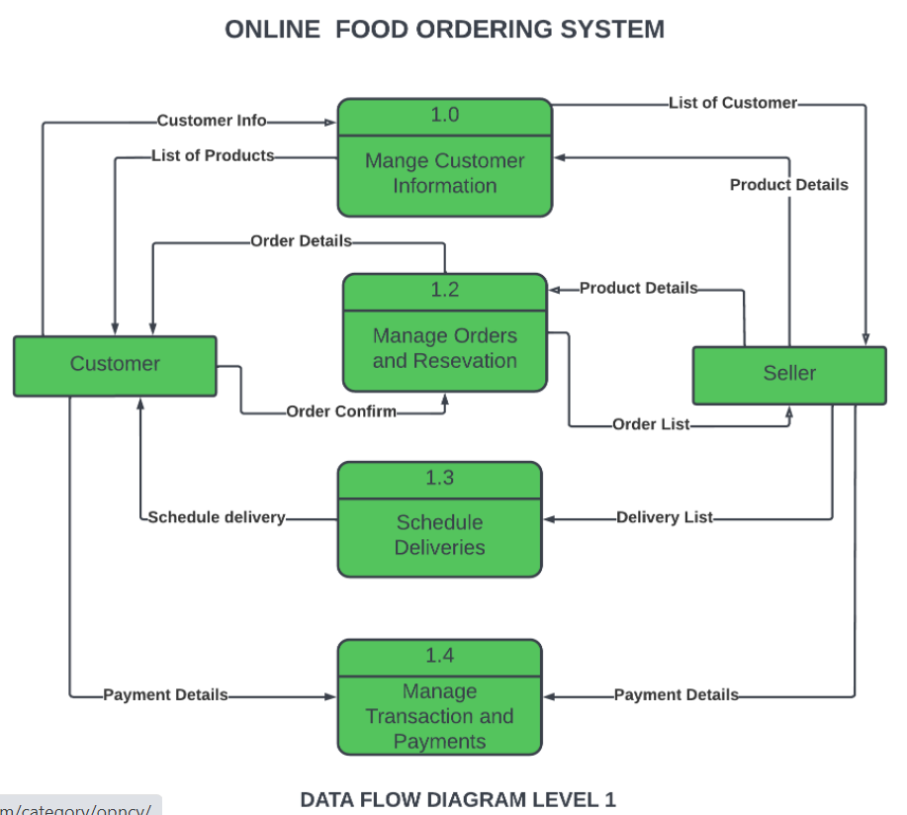

**Second Level DFD (2ND)**

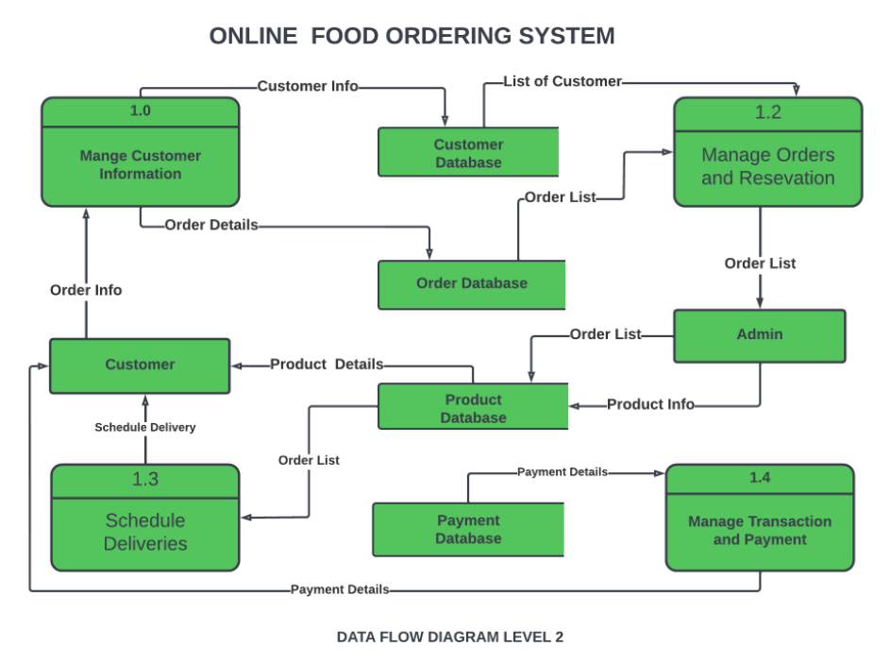

**Screen Shorts of website :-**

**Website interface**

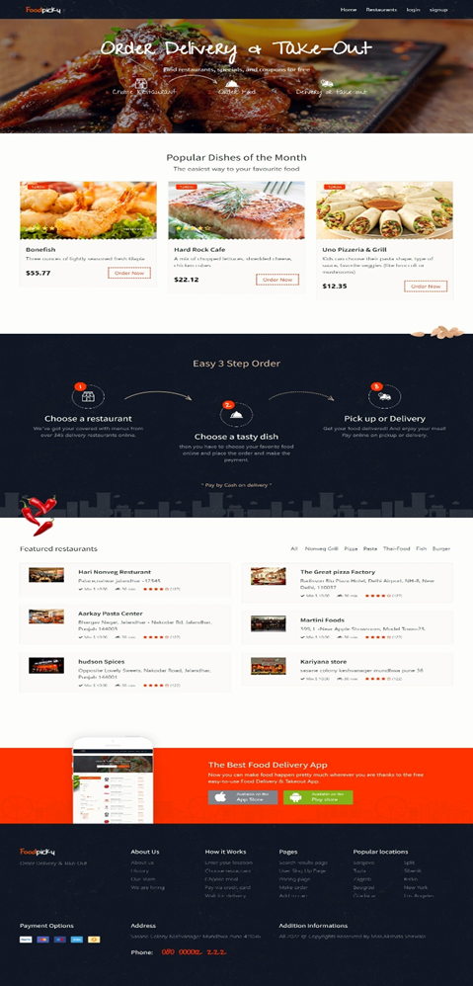

**Singup Screen at startup of website :-**

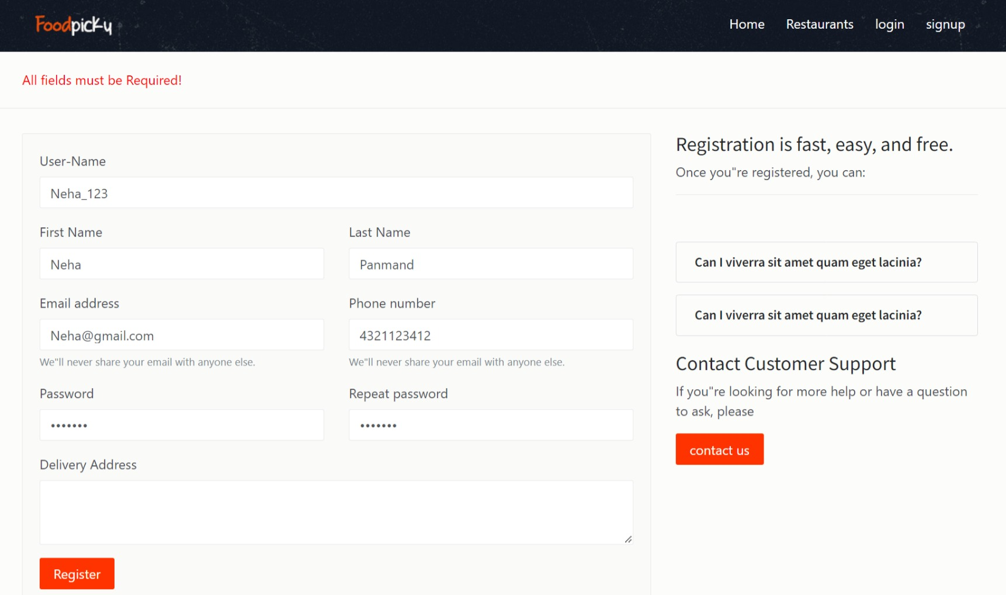

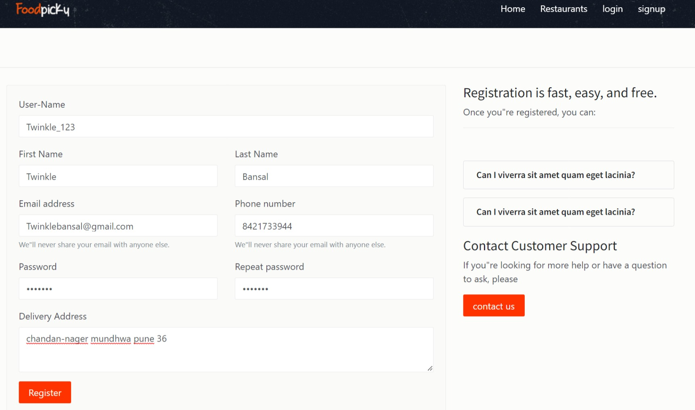**After All Fields Are Filled :-**

**successful signup / registration :-**

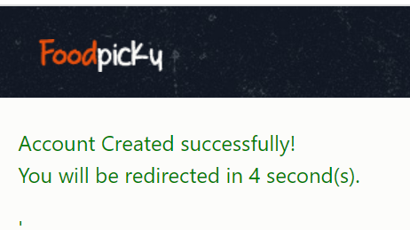

**Same username is filled by another person :-**

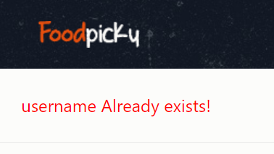

**Login Screen at start up of website :-**

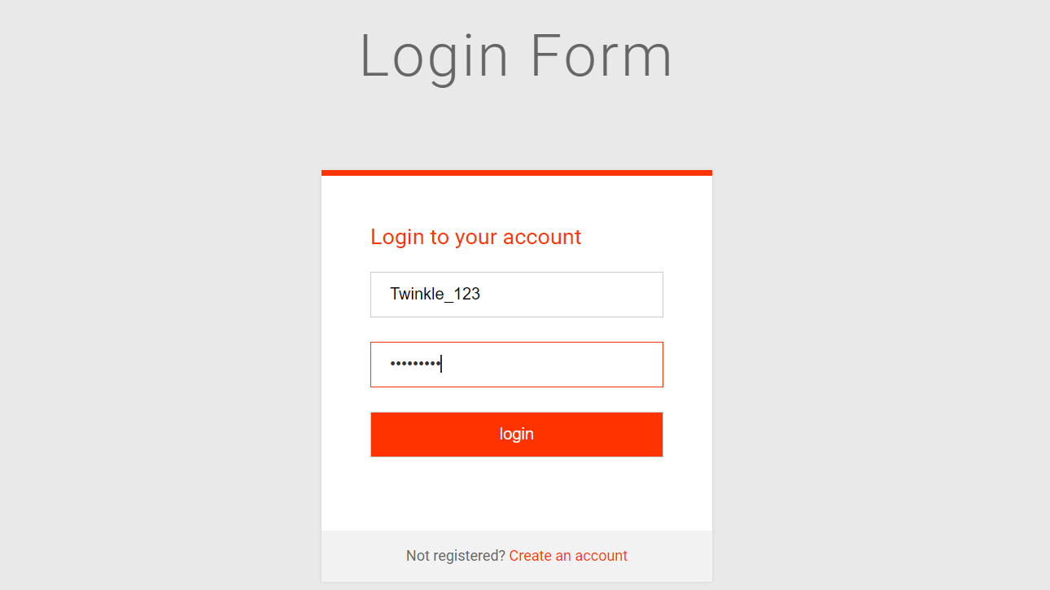

**If wrong username or password is inserted :-**

**OUTPUT :-**

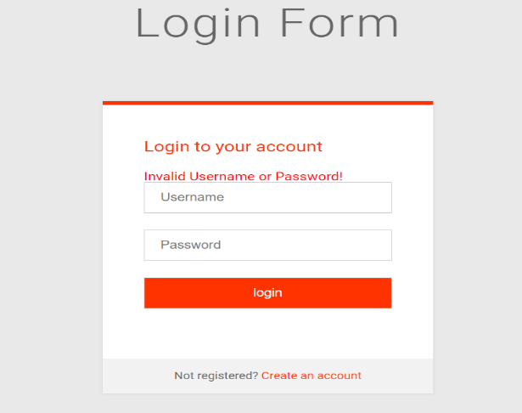

**After successful login :-**

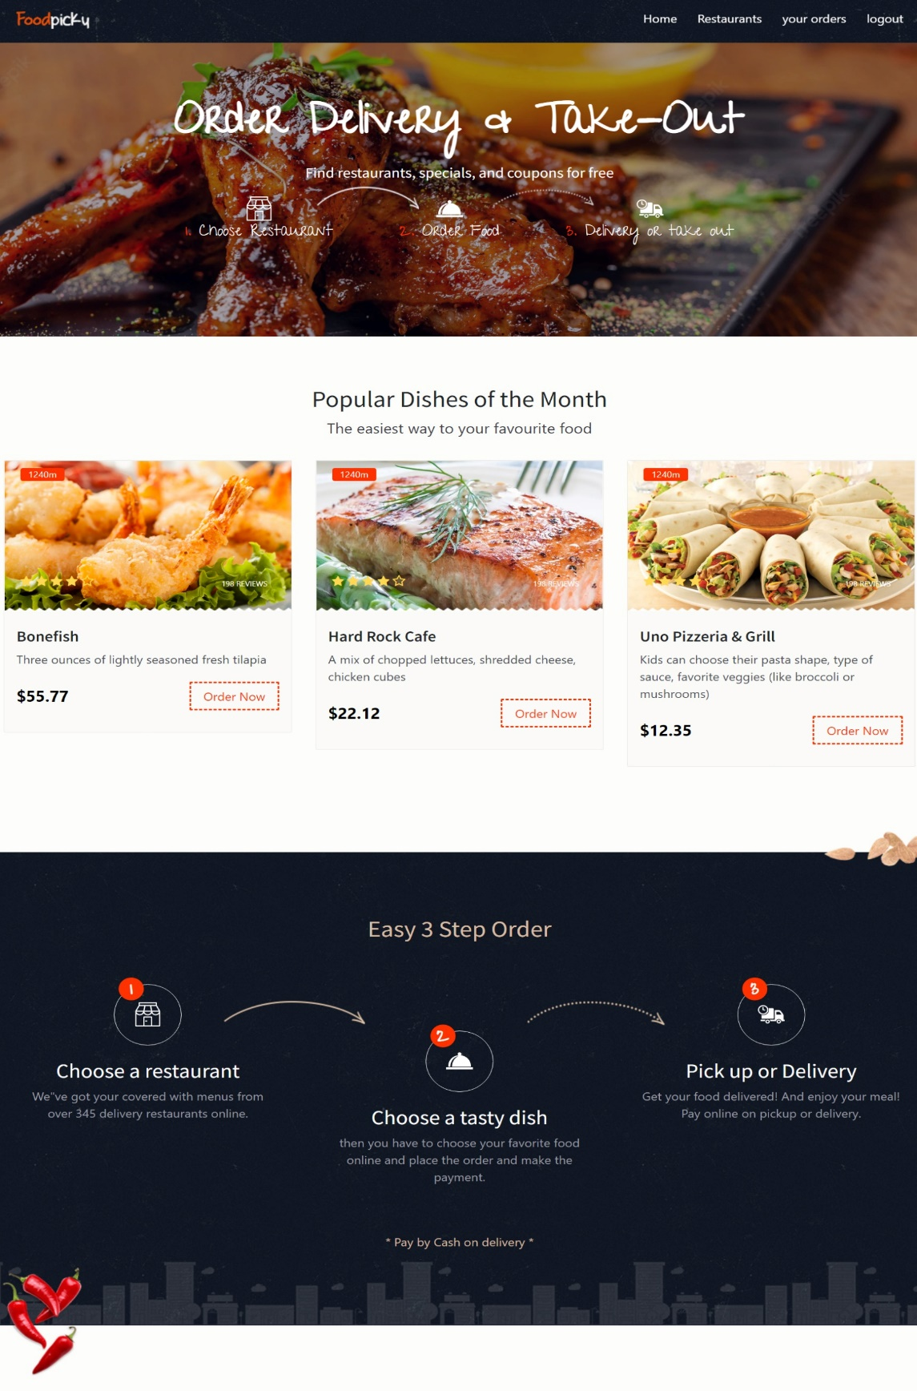

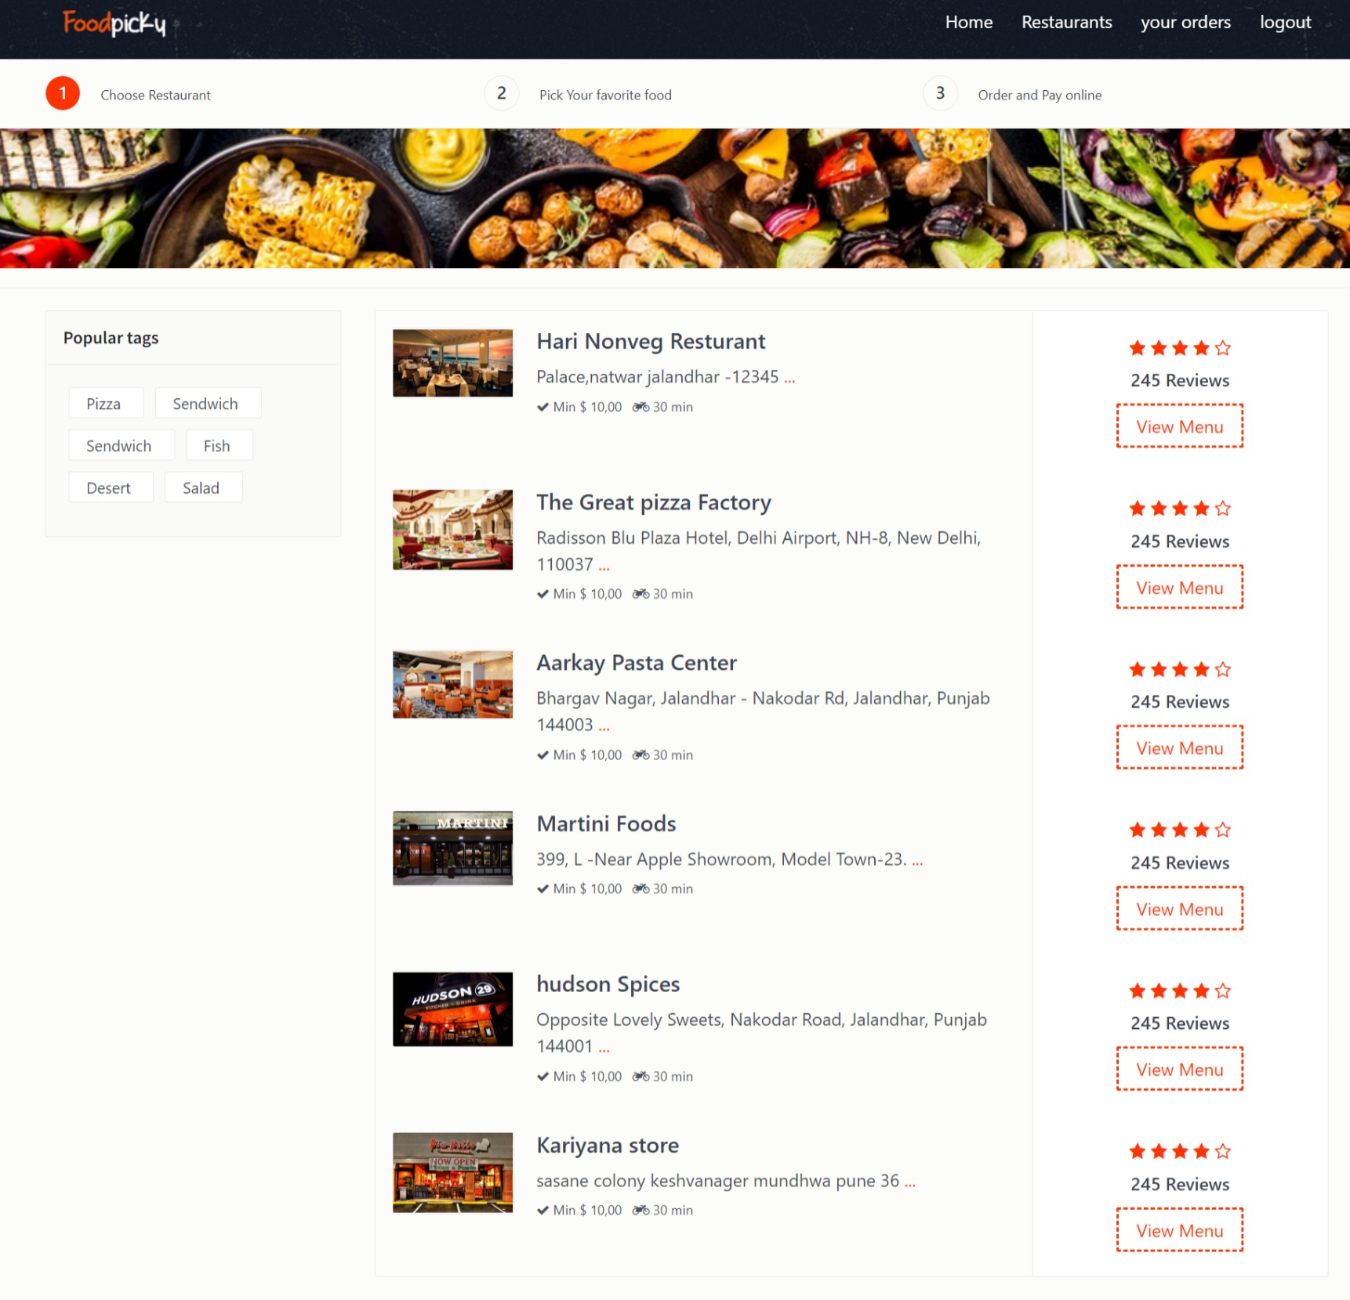**Choose your favoriate resturants :-**

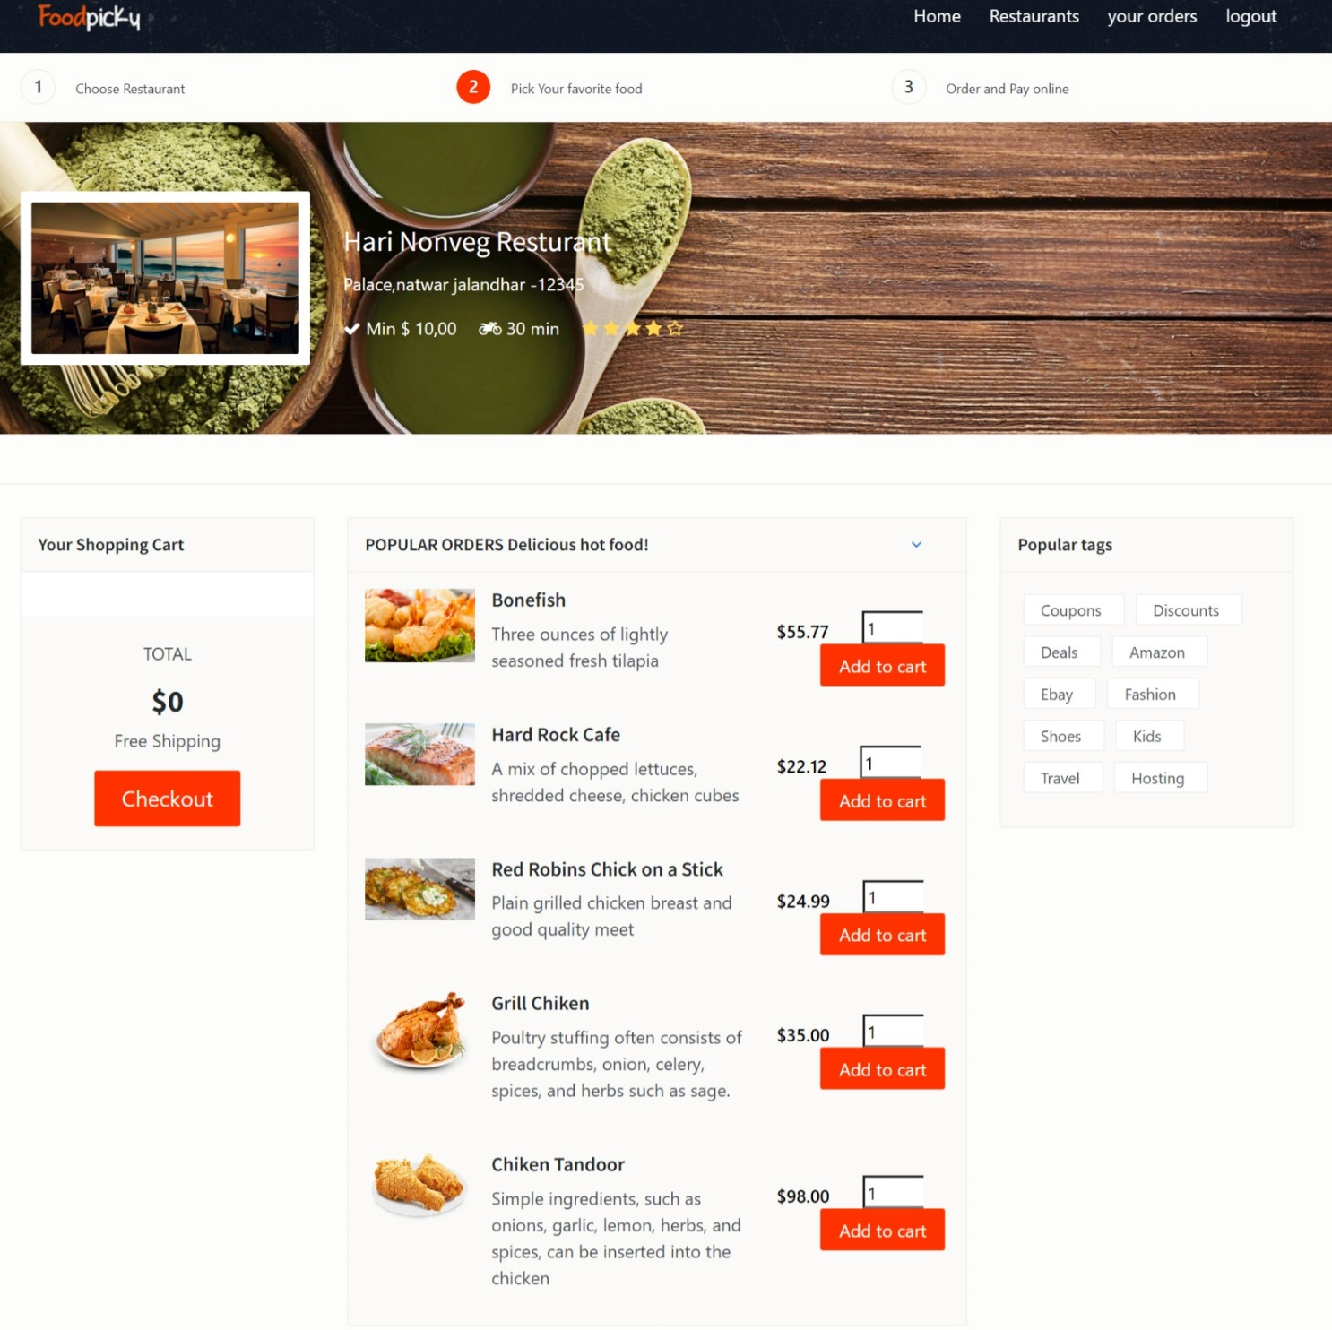 **Pick your favoriate food in the restaurant :-**

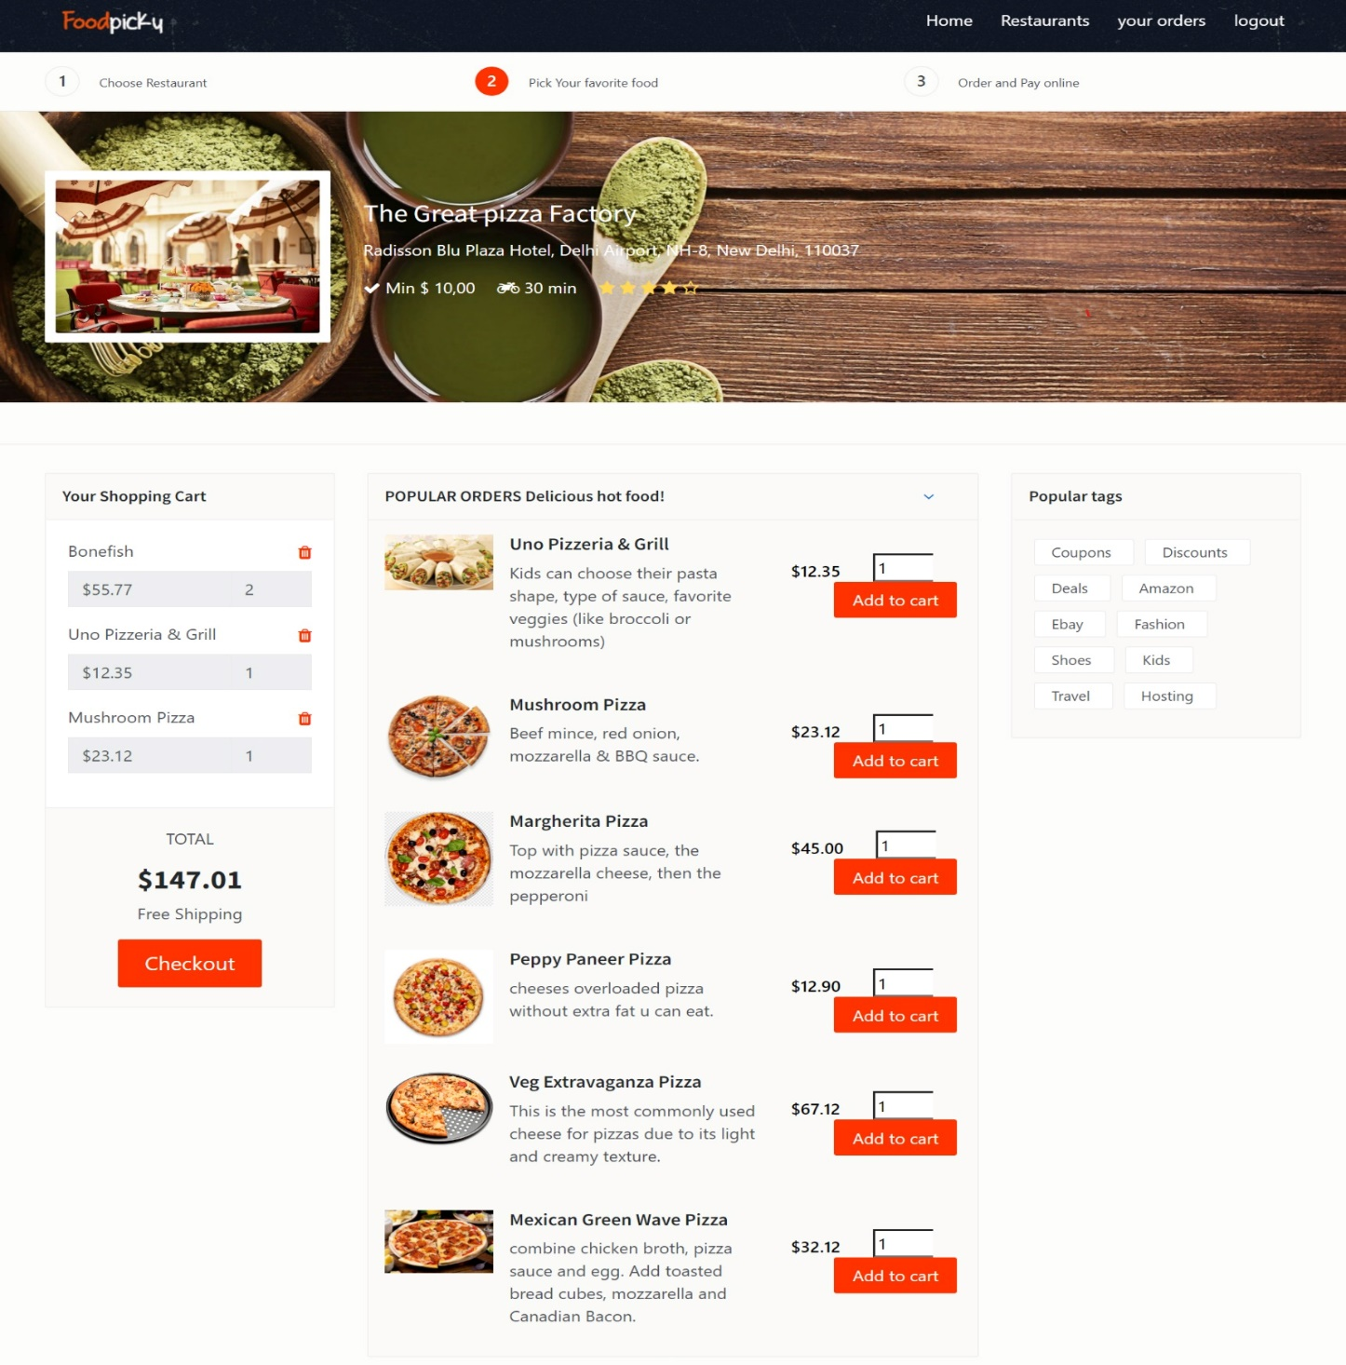**add to the cart and checkout :-**

**order and pay the bill :-**

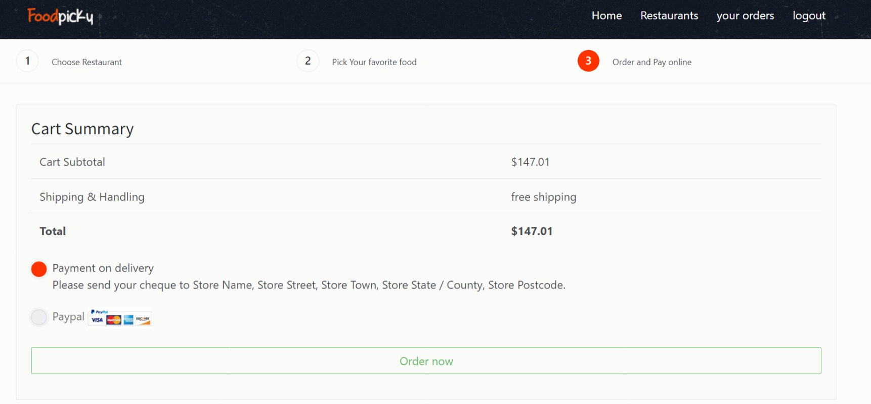

**Confirm your food order :-**

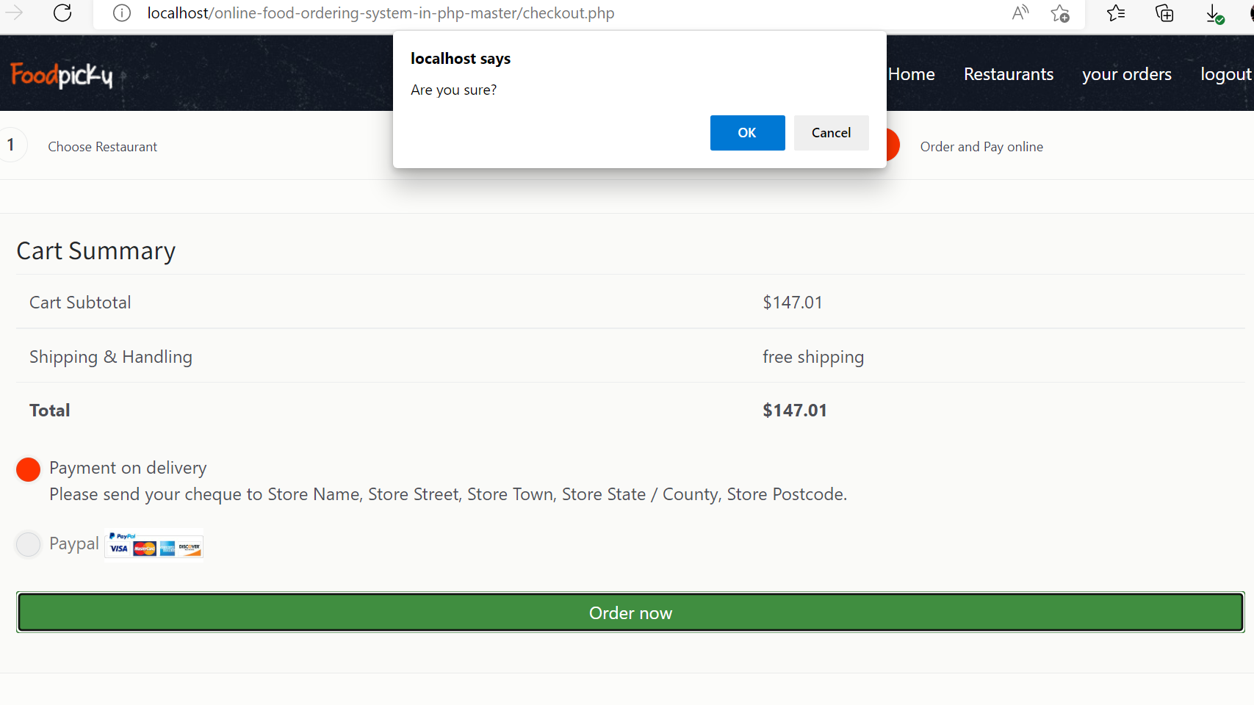

**successful transaction the order is placed :-**

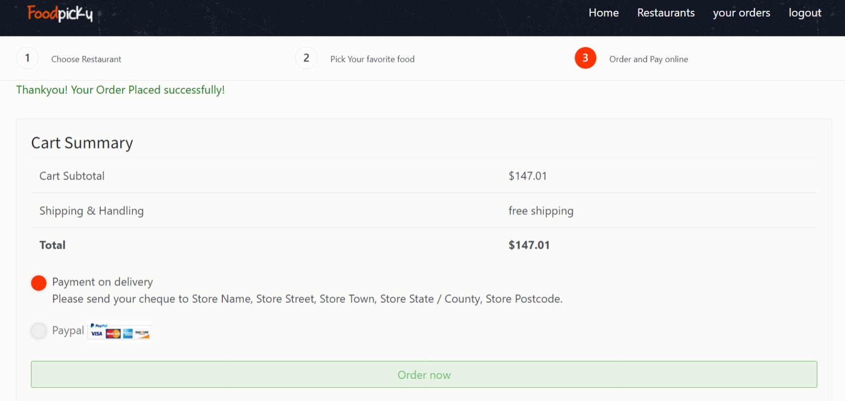

**Track your food order :-**

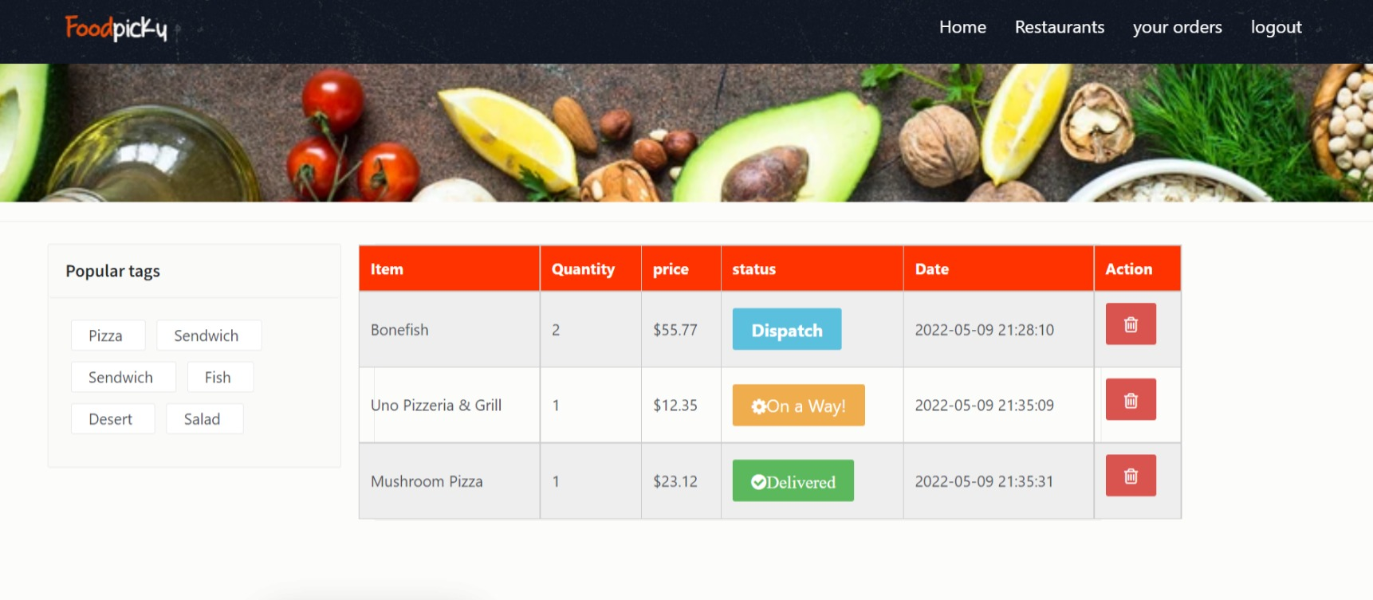

**Administration login :-**

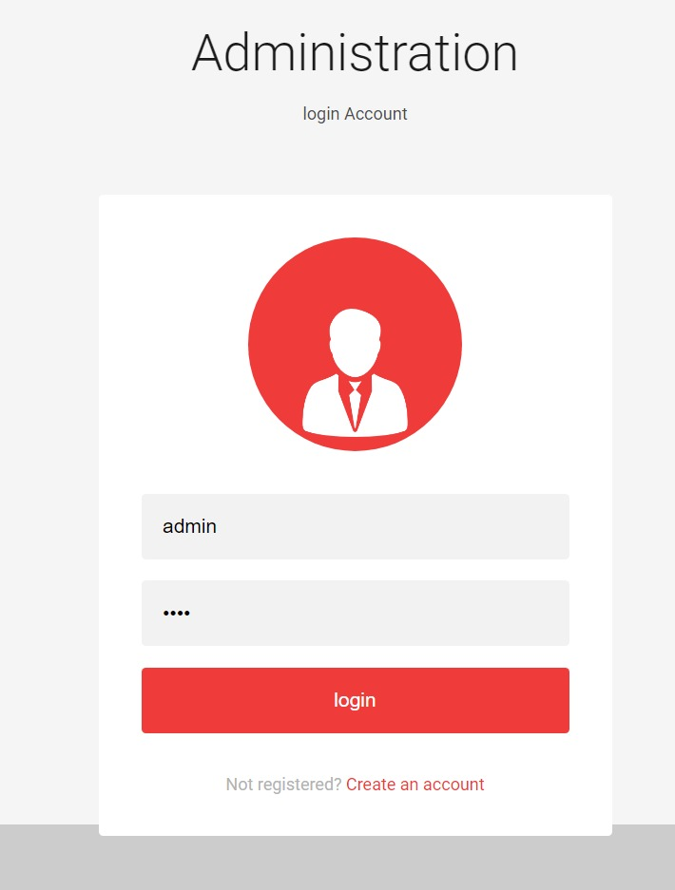

**After successful admin login :-**

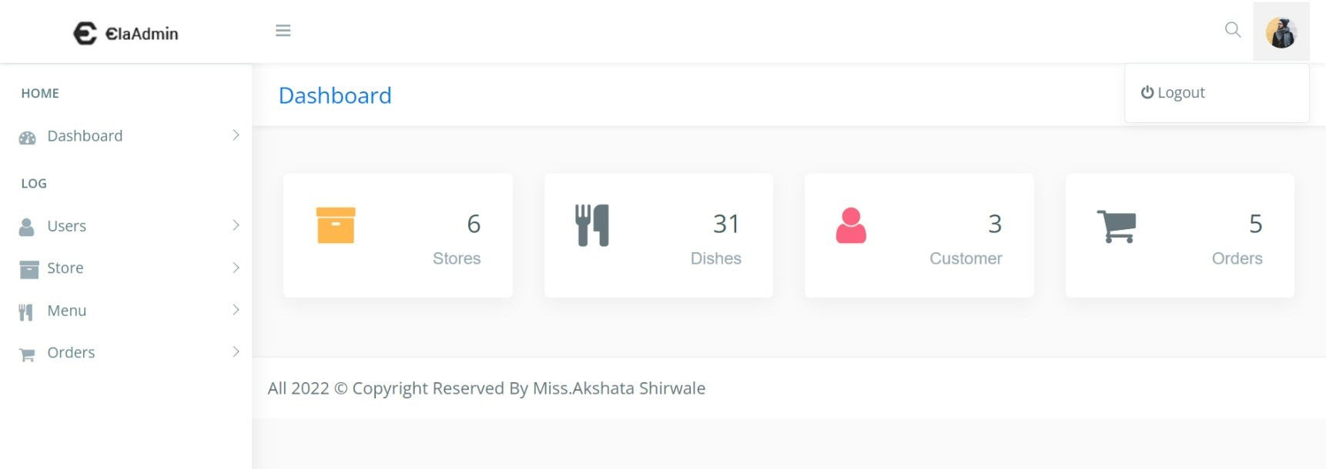

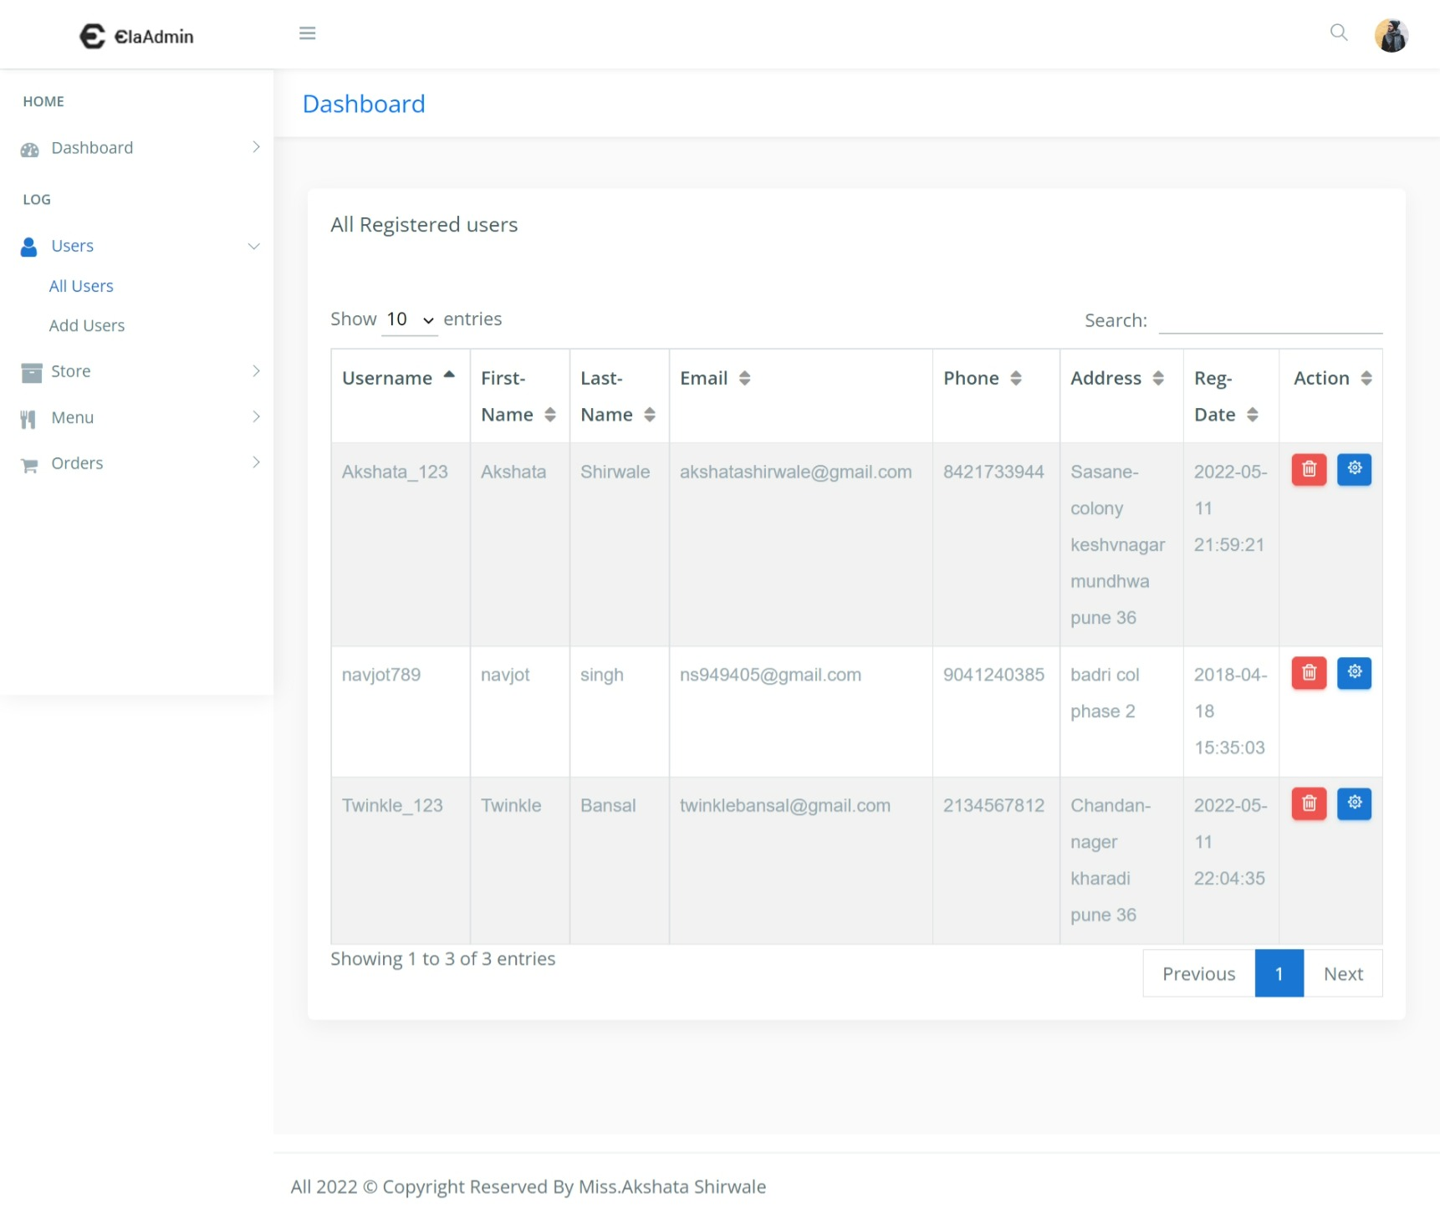**All User dashboard :-**

**Form to add the new user :-**

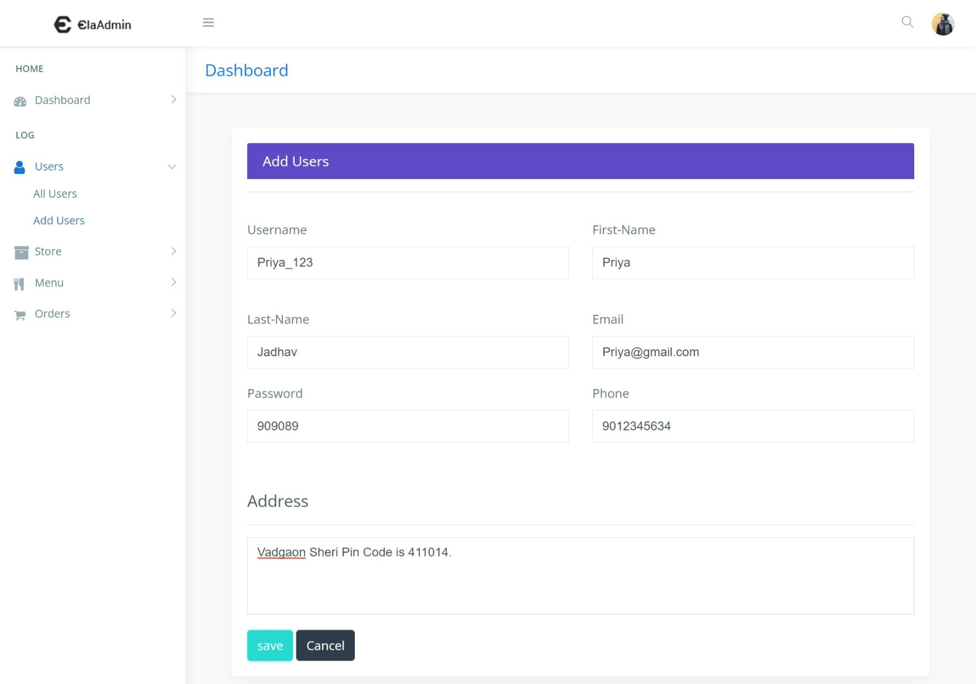

**After successfully add the user :-**

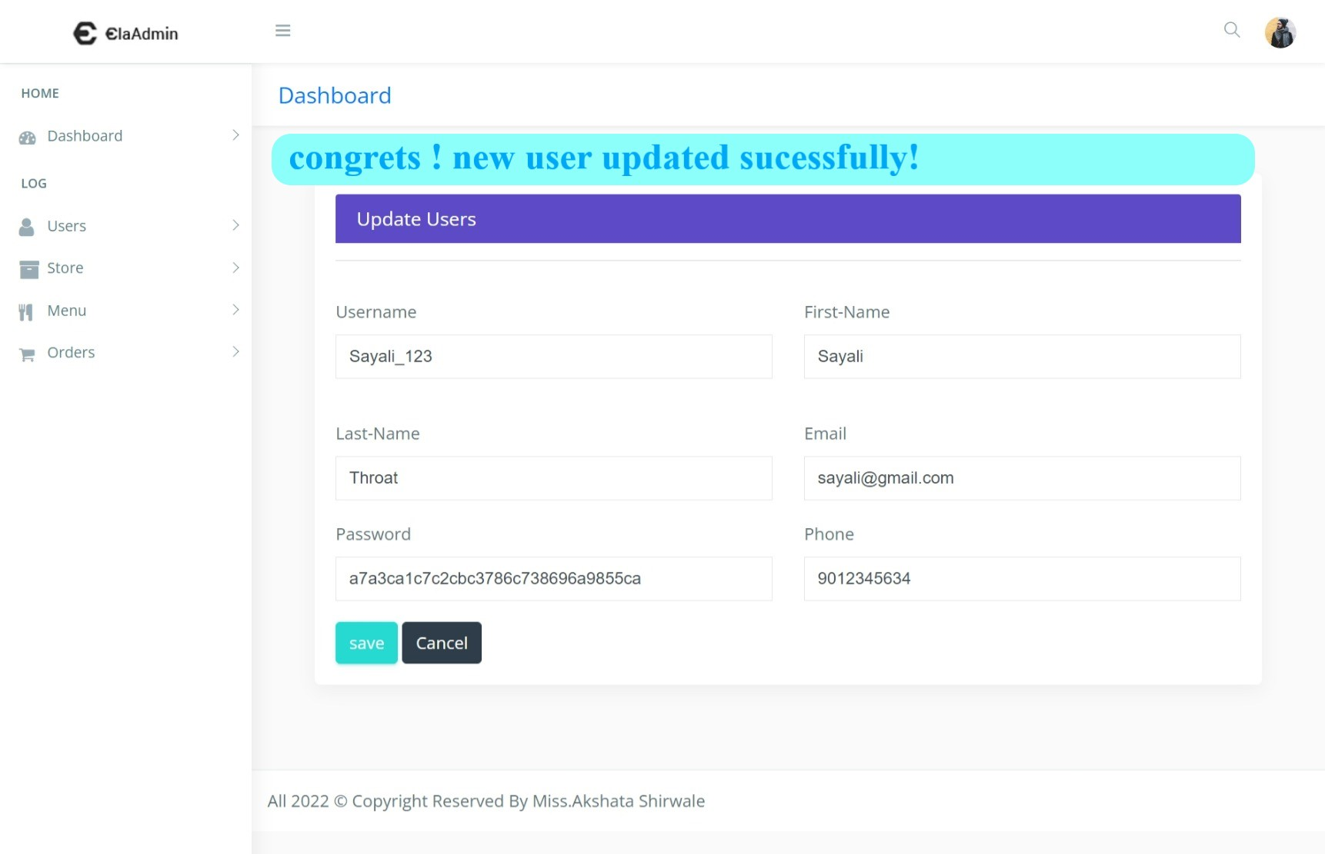

**Display new user on dashboard :-**

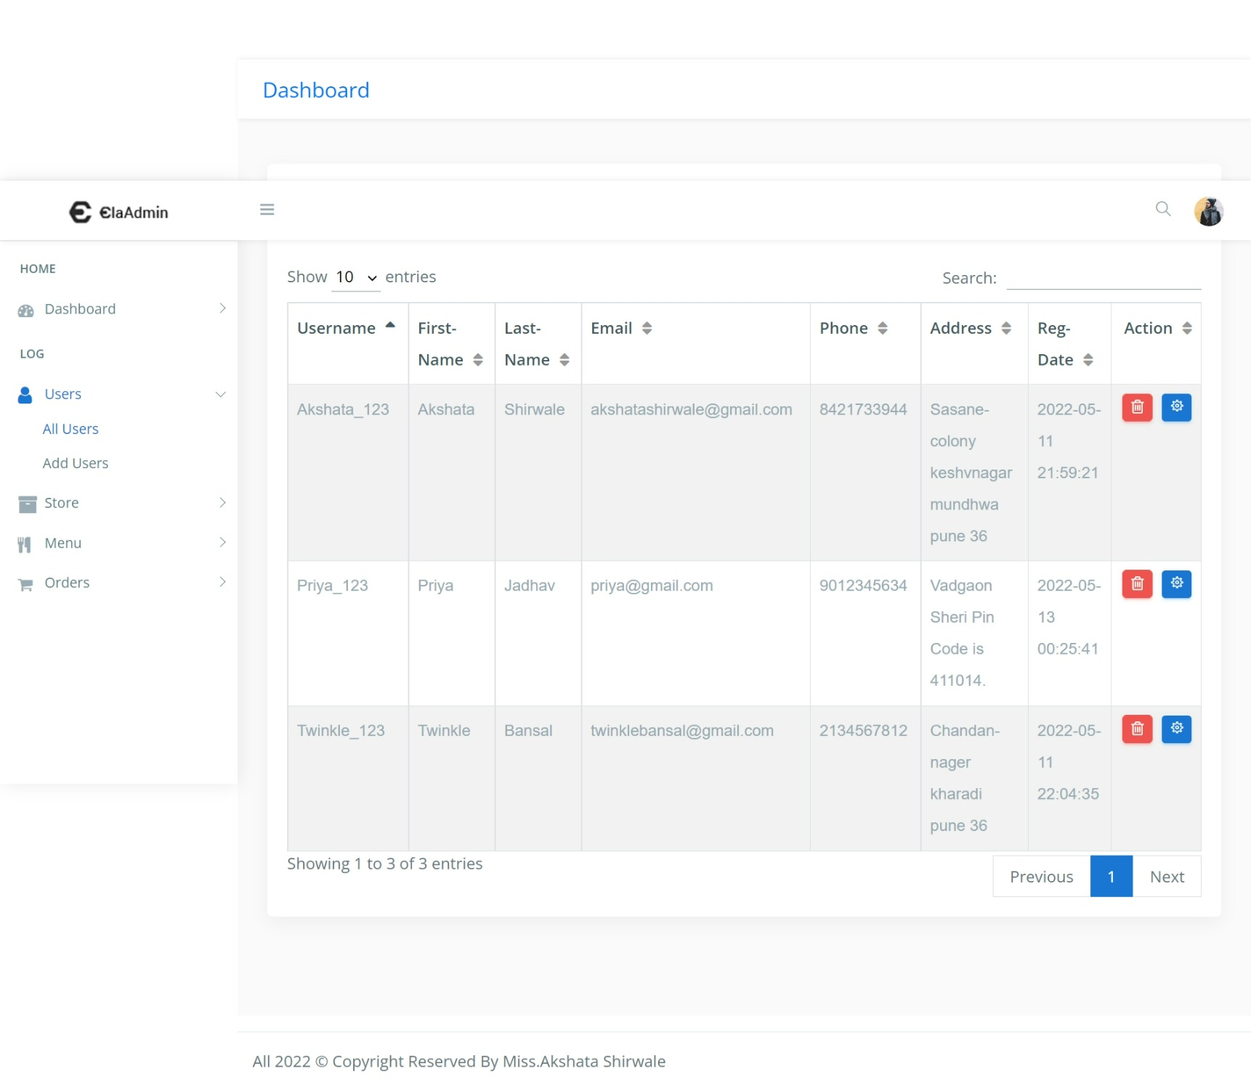

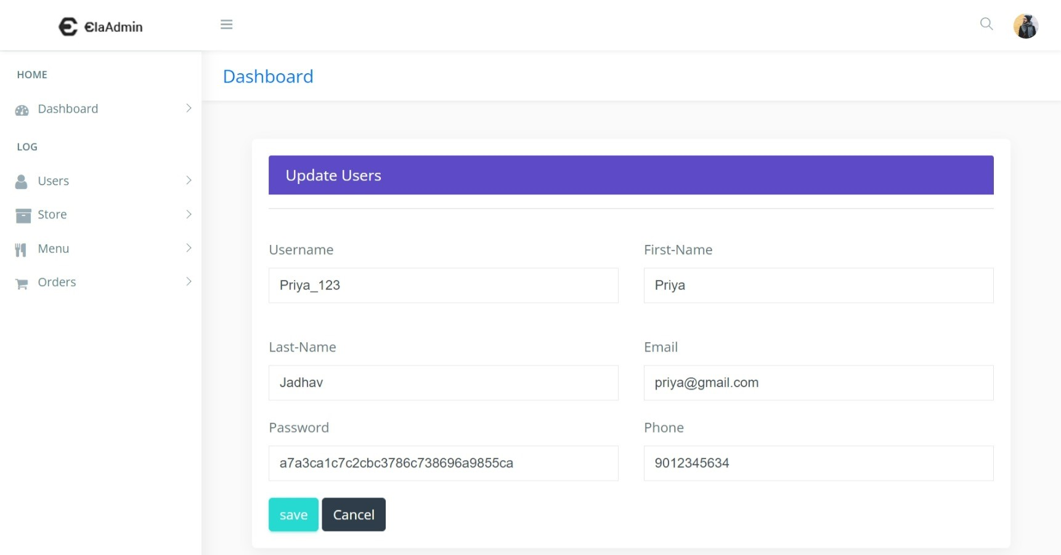**Update the user :-**

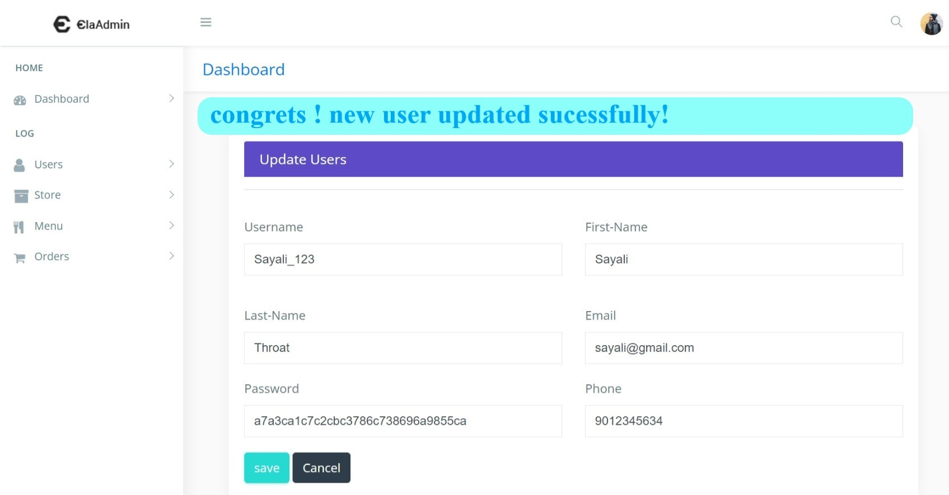**After successfully add the user :-**

**Display updated user on dashboard :-**

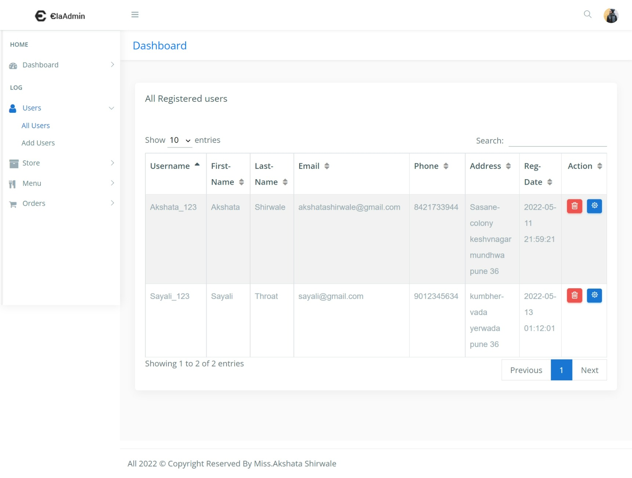

**Delete existing user :-**



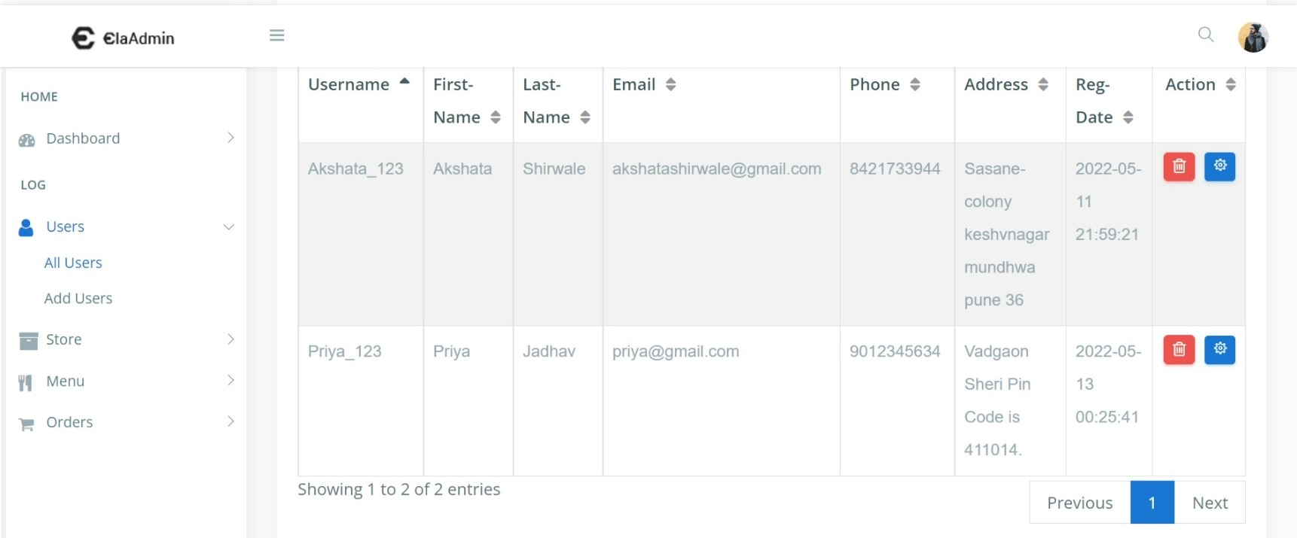**After successfully deleted user :-**

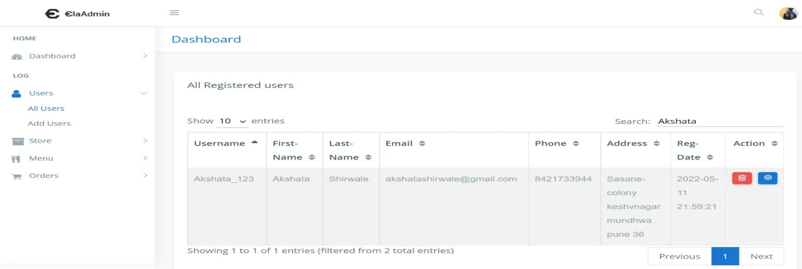**Search existing user :-**

**All store dashboard :-**

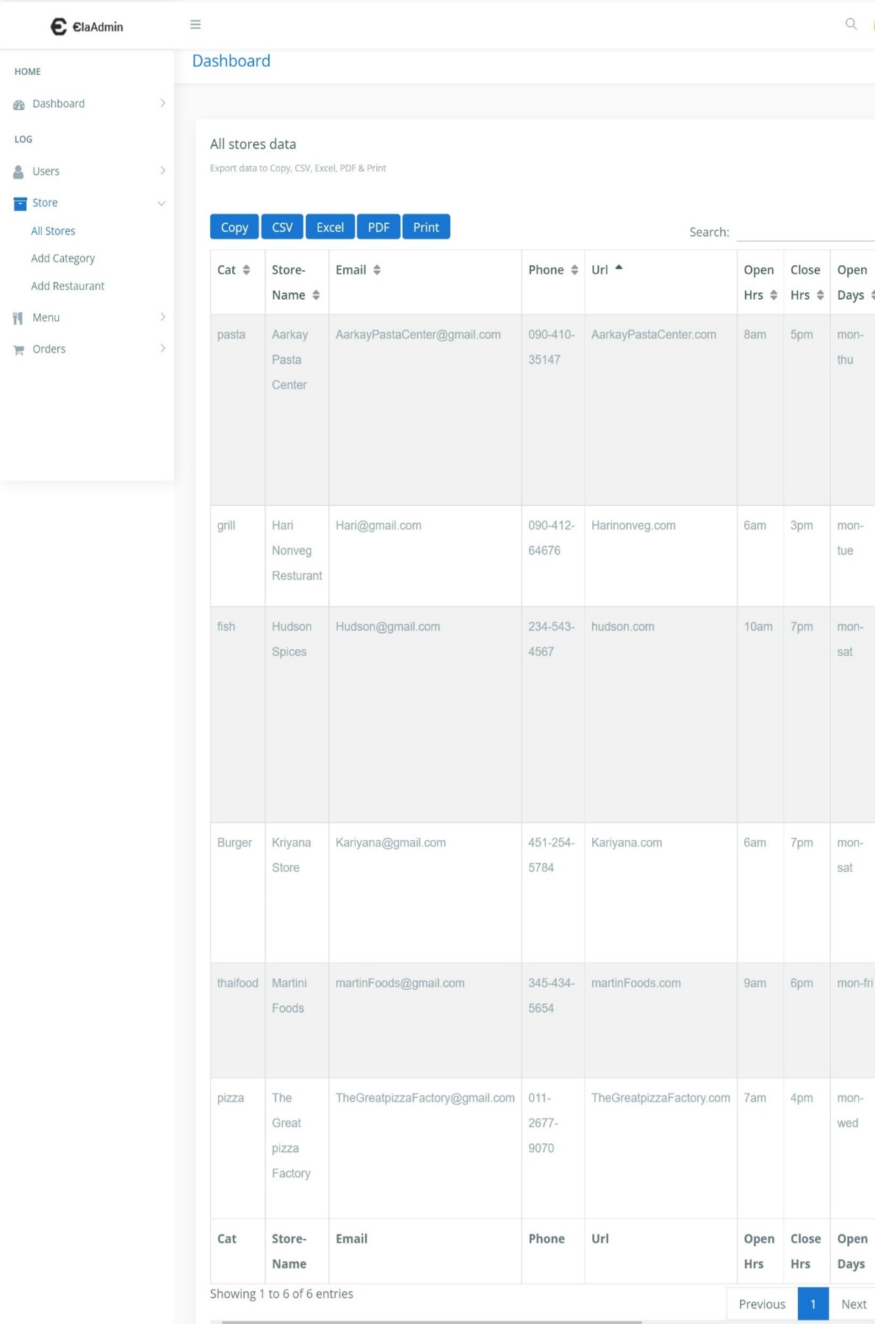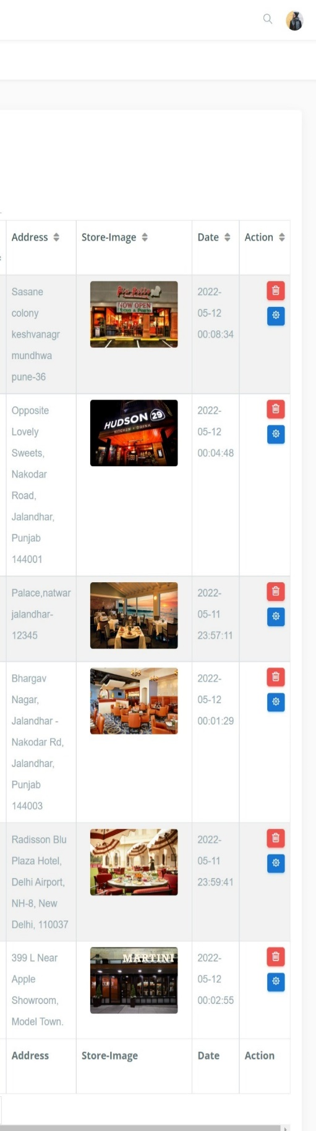

**Add Restaurant Category :-**

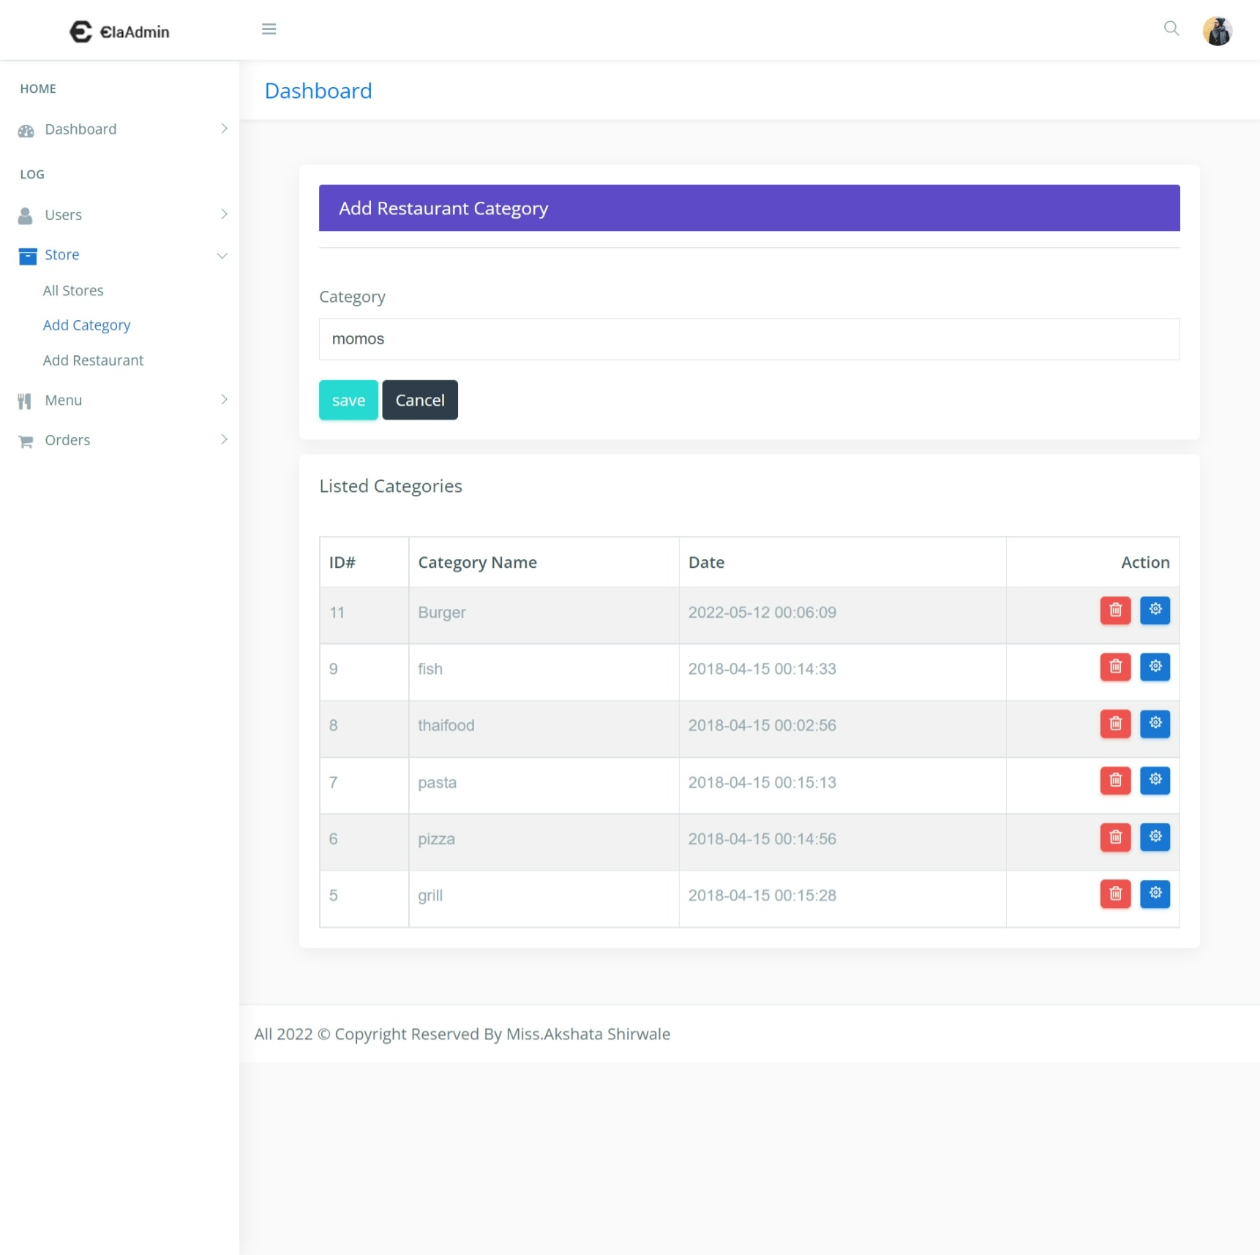

**After successfully added the restaurant category :-**

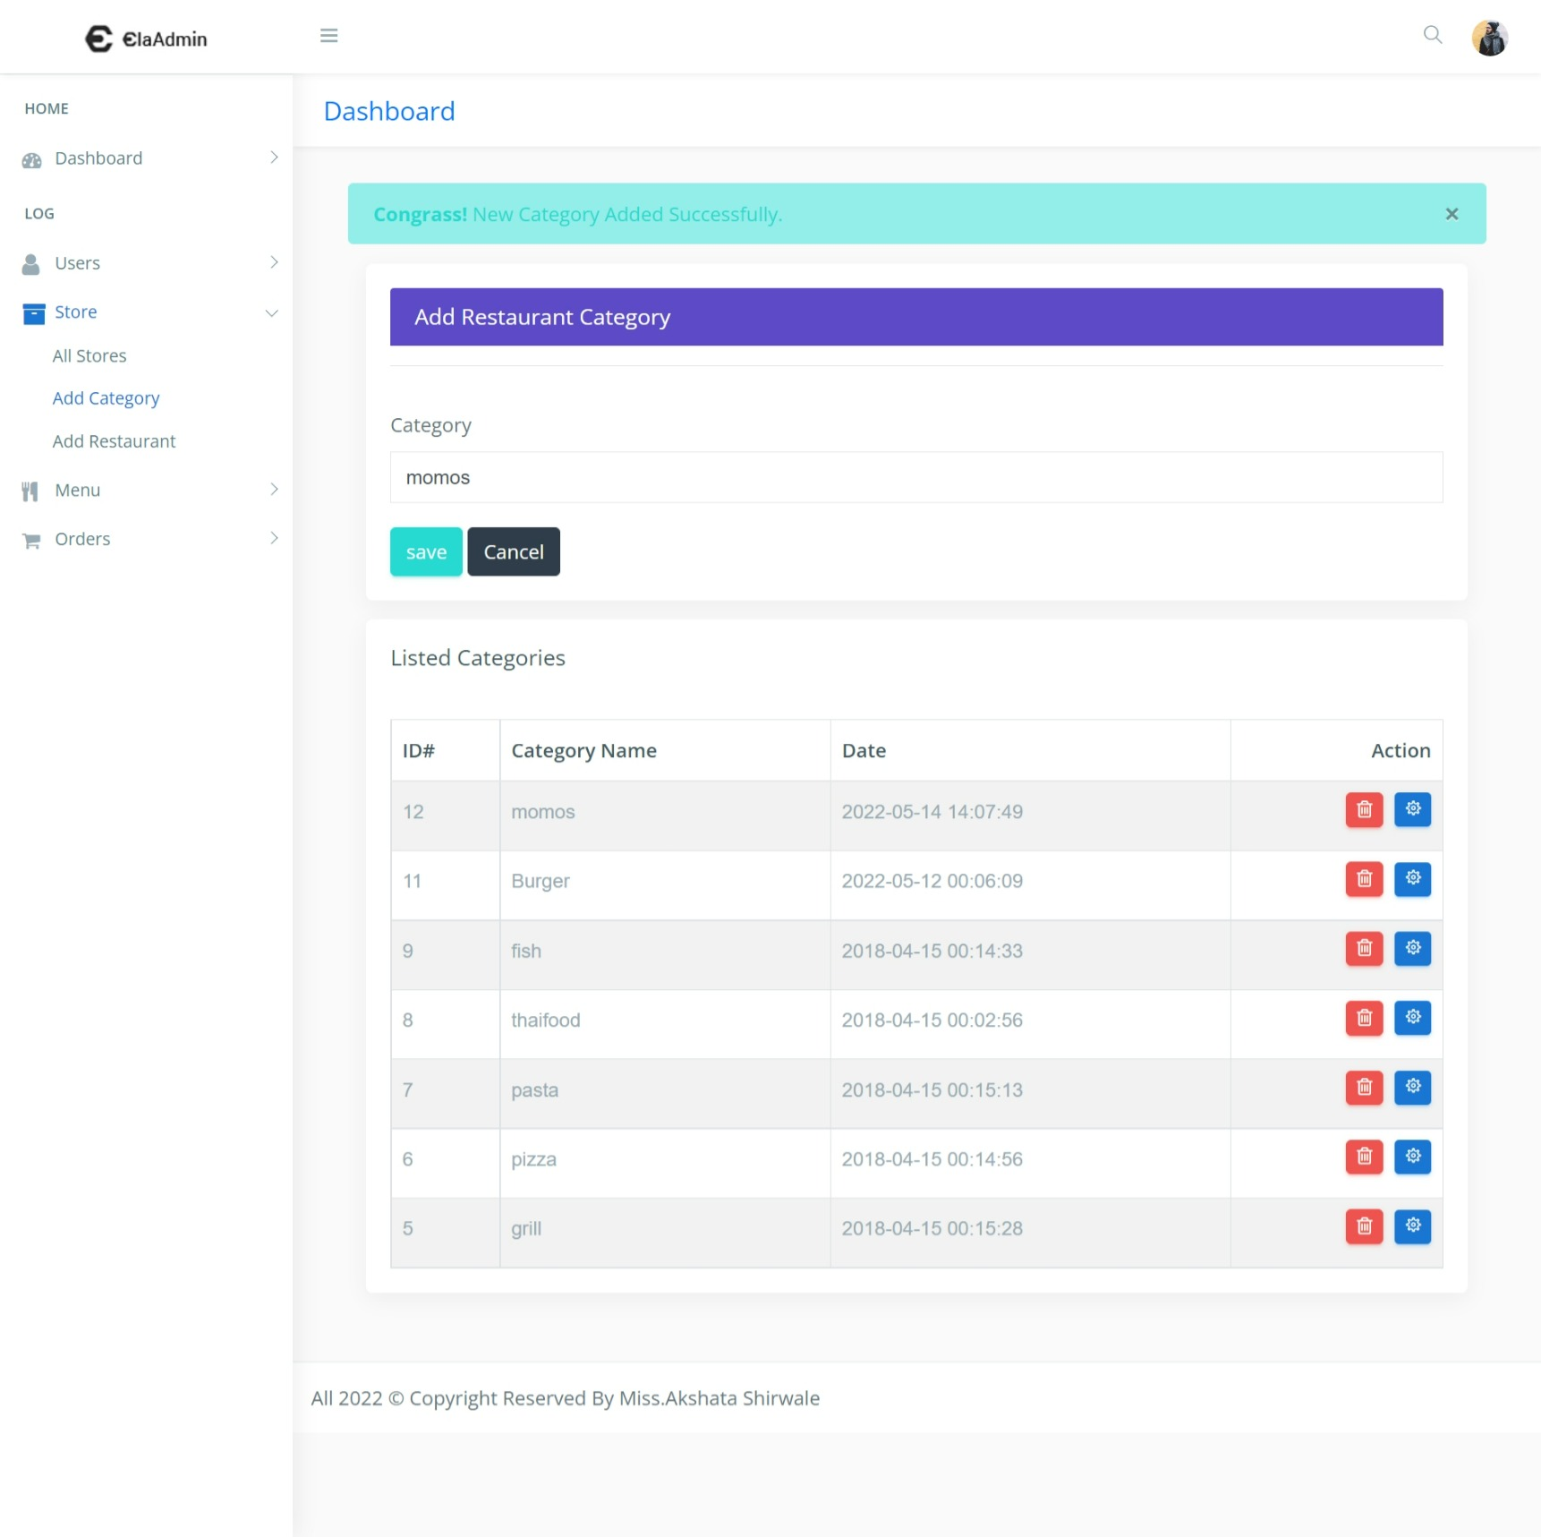

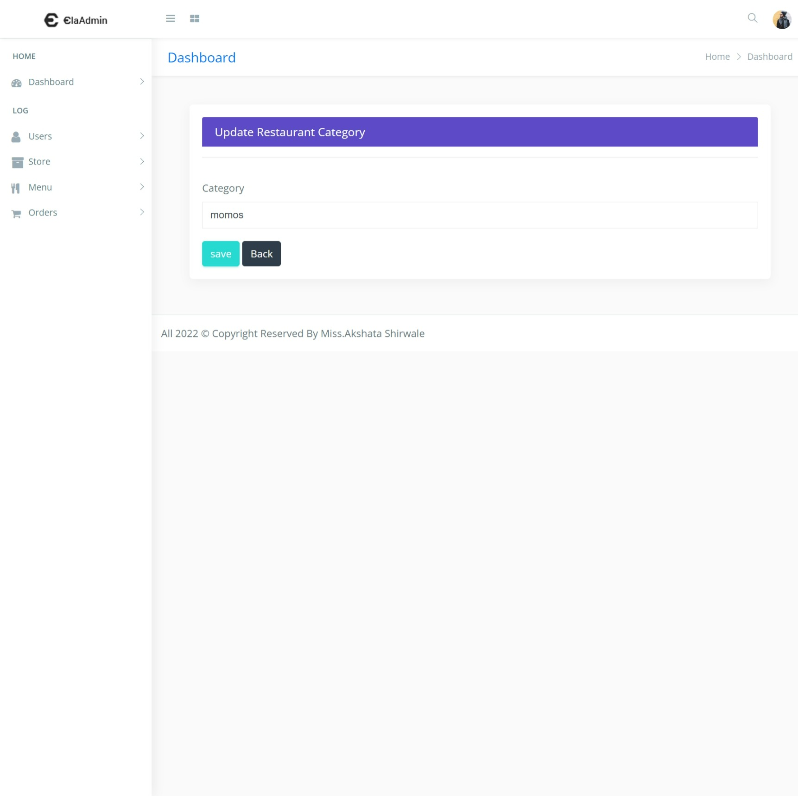**update Restaurant Category :-**

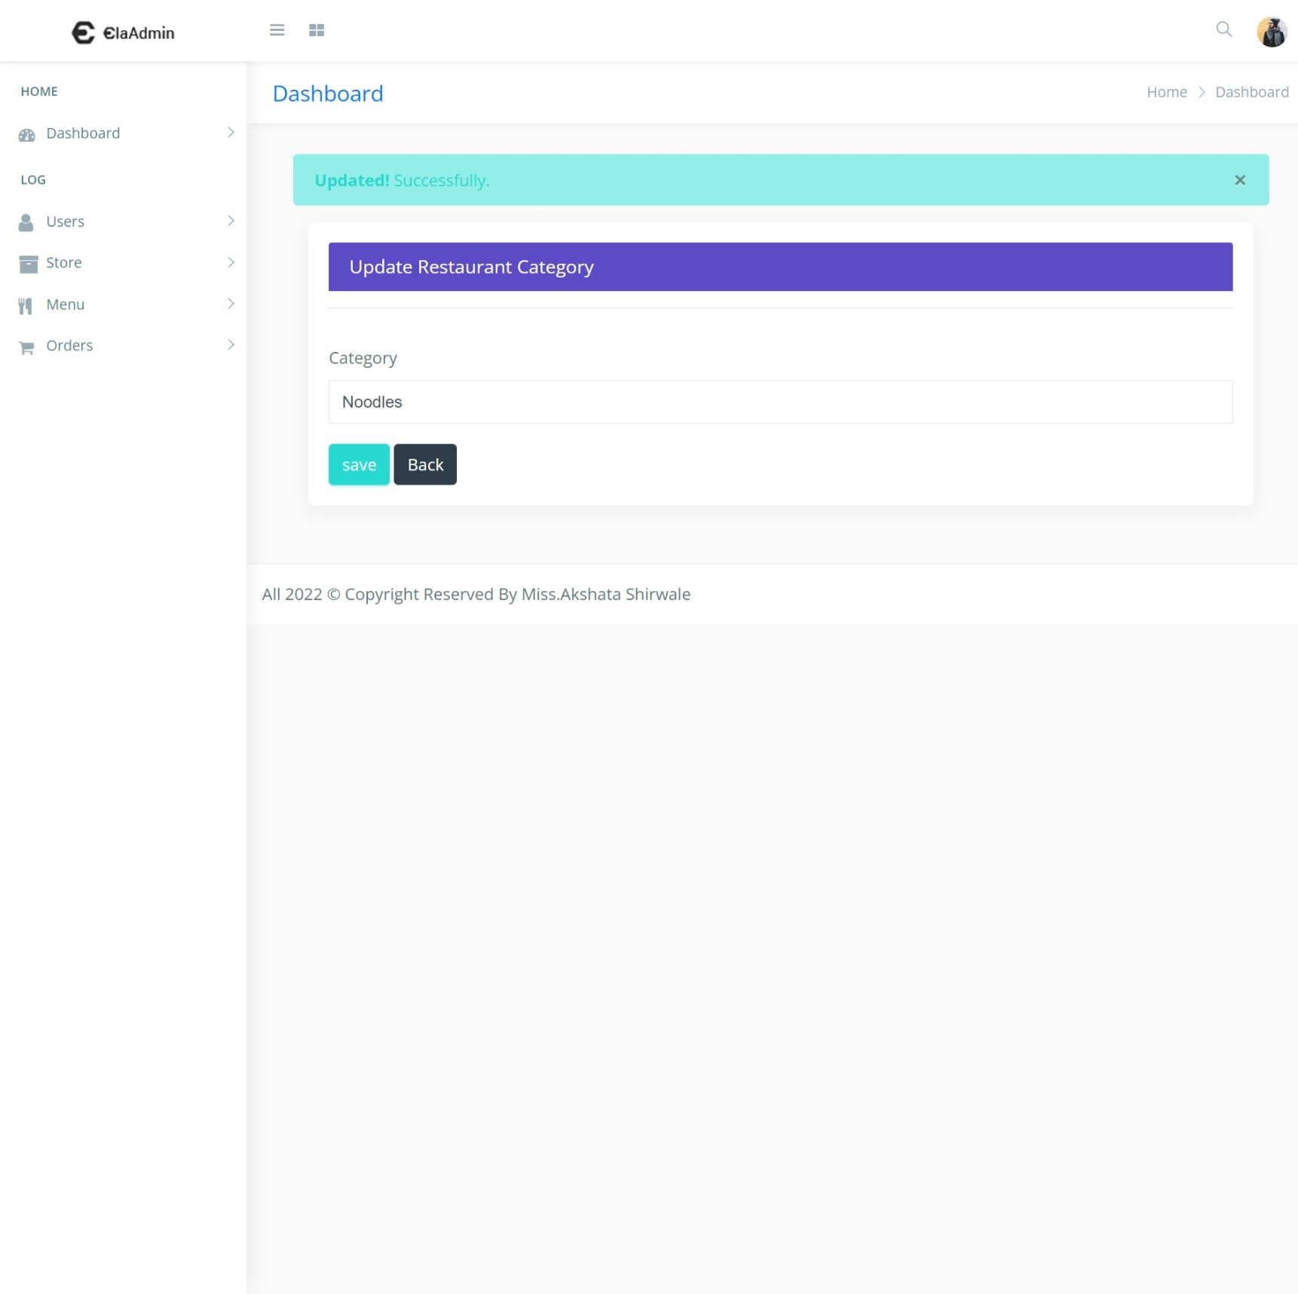**After successfully updated the restaurant category :-**

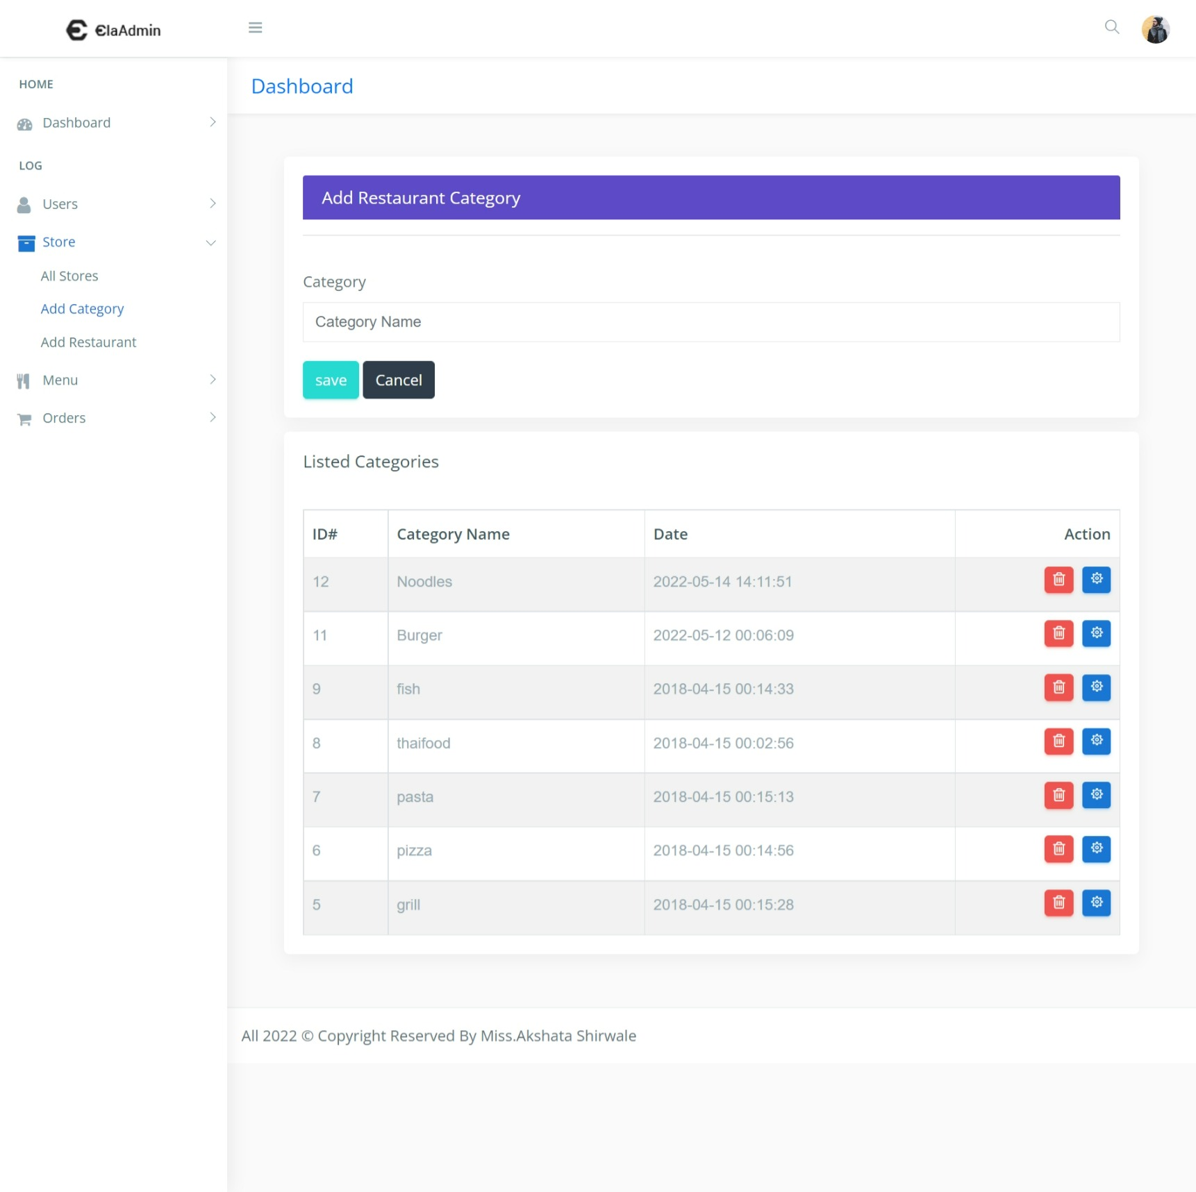**Display upated records on store dashboard :-**

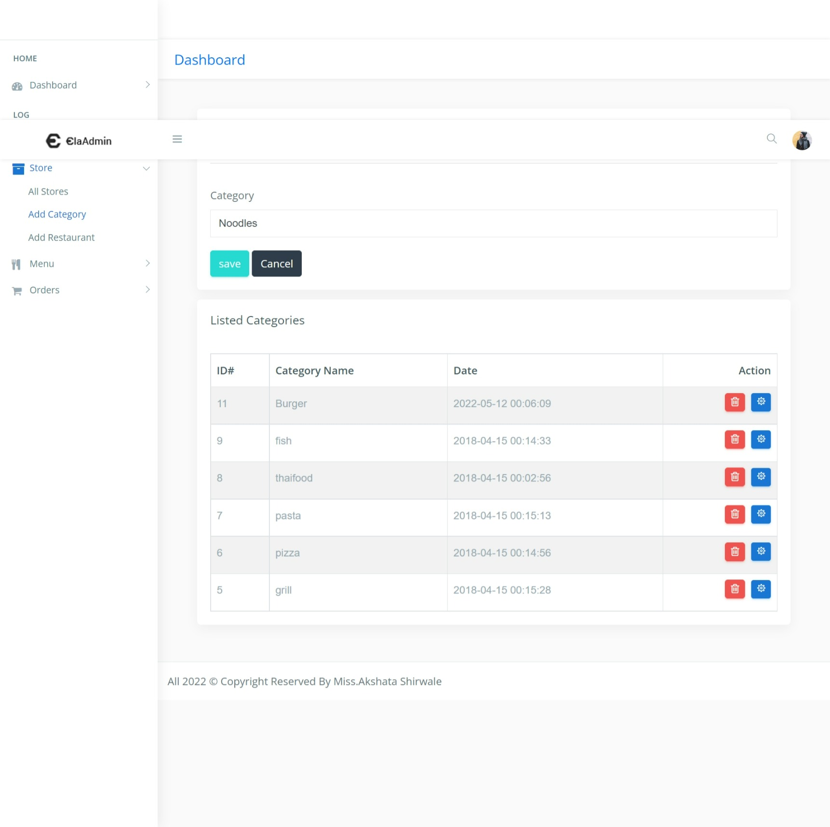**Delete the restaurant catgory:-**

**Add new restaurant :-**

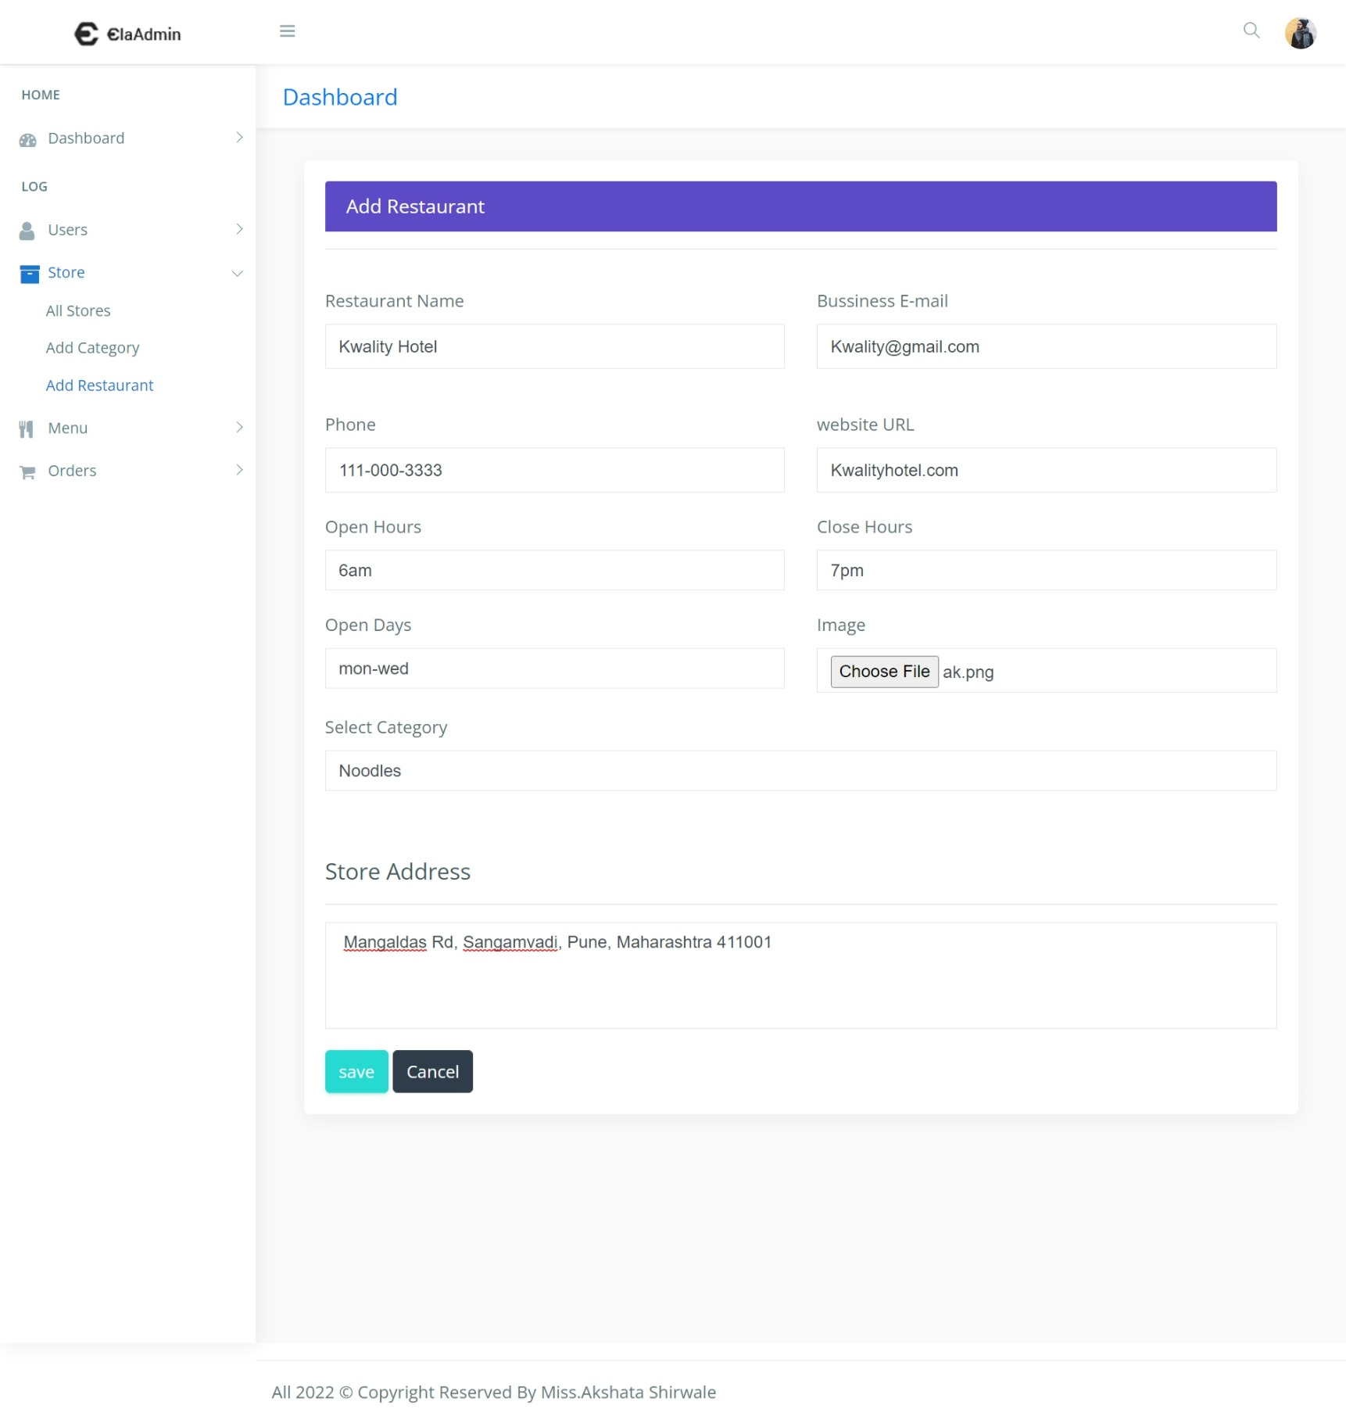

**After successfully added the new restaurant :-**

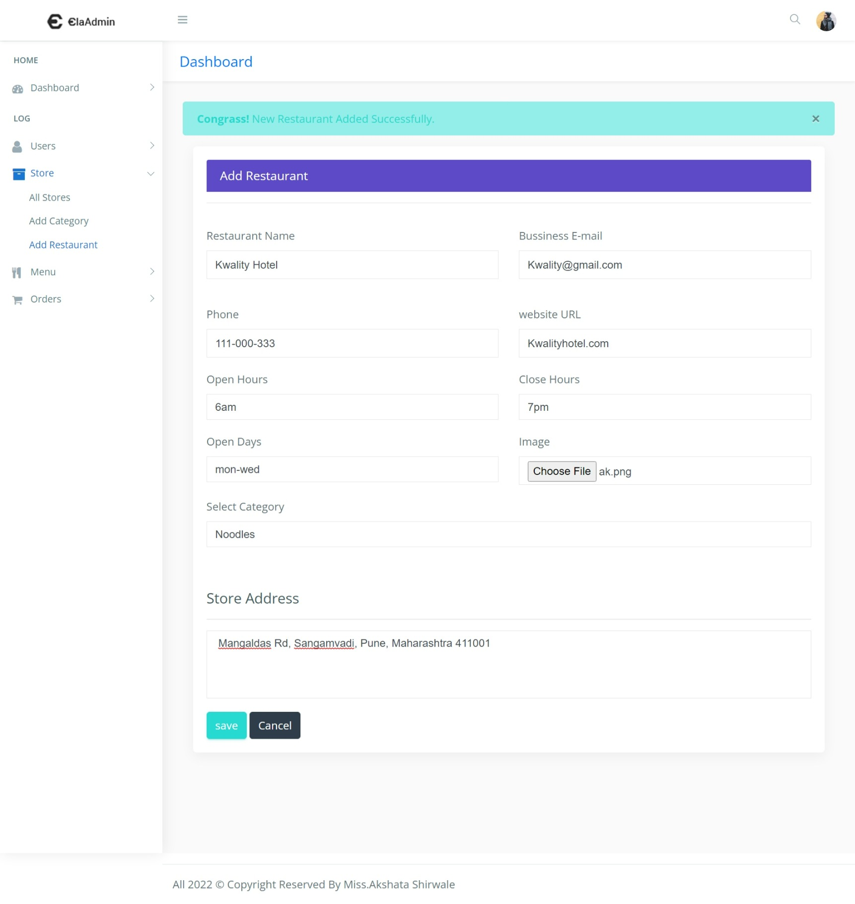

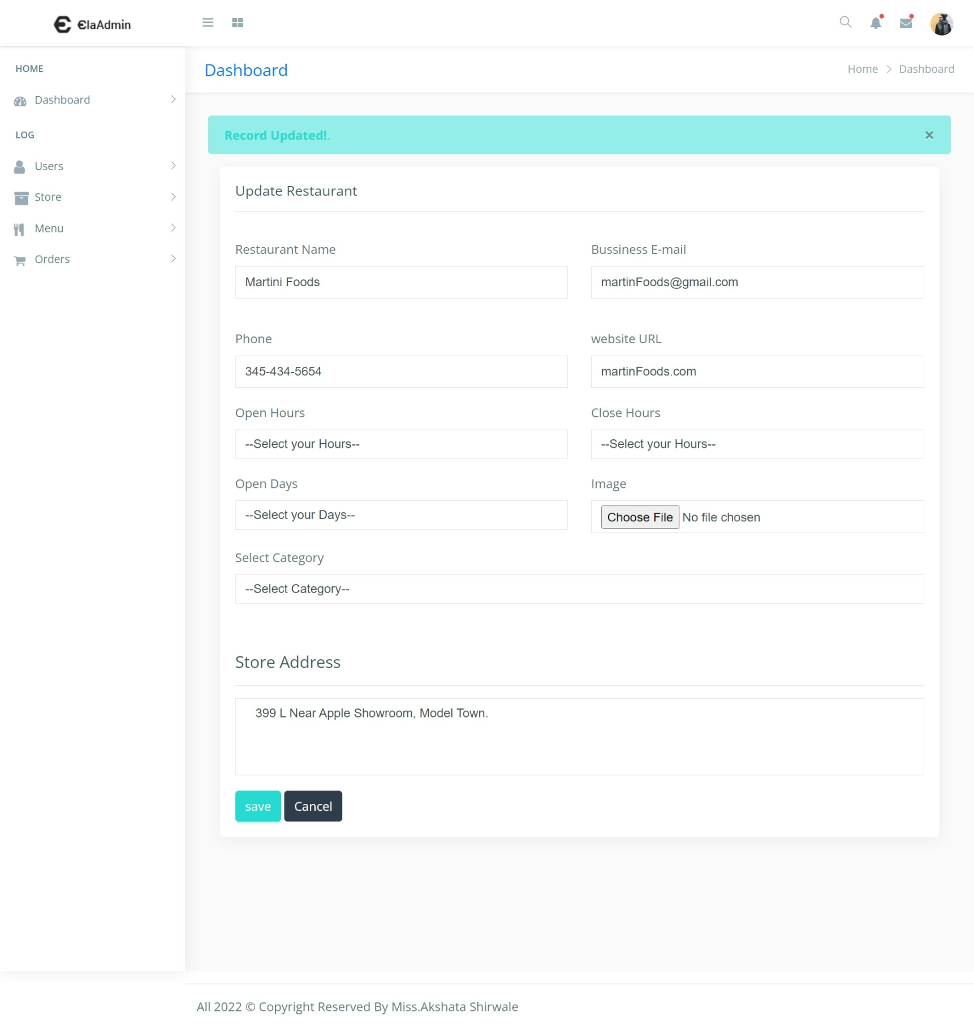**Update restaurant :-**

**SEARCH RESTAURANT :-**

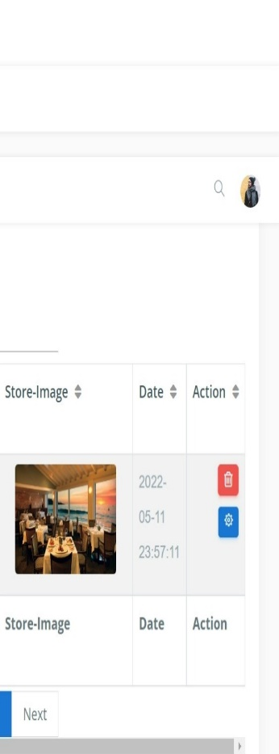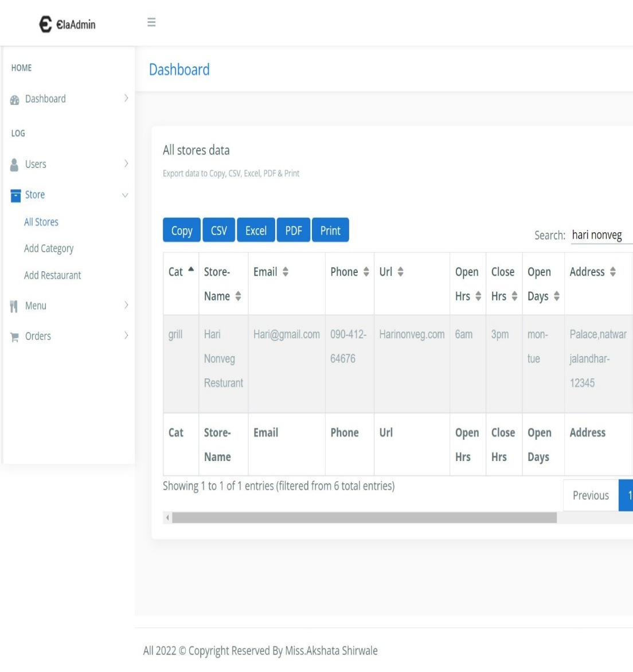

**Display upated records on all store dashboard :-**

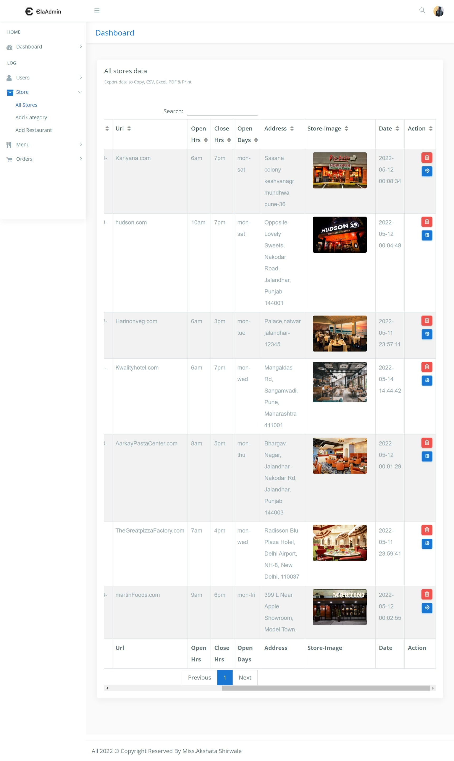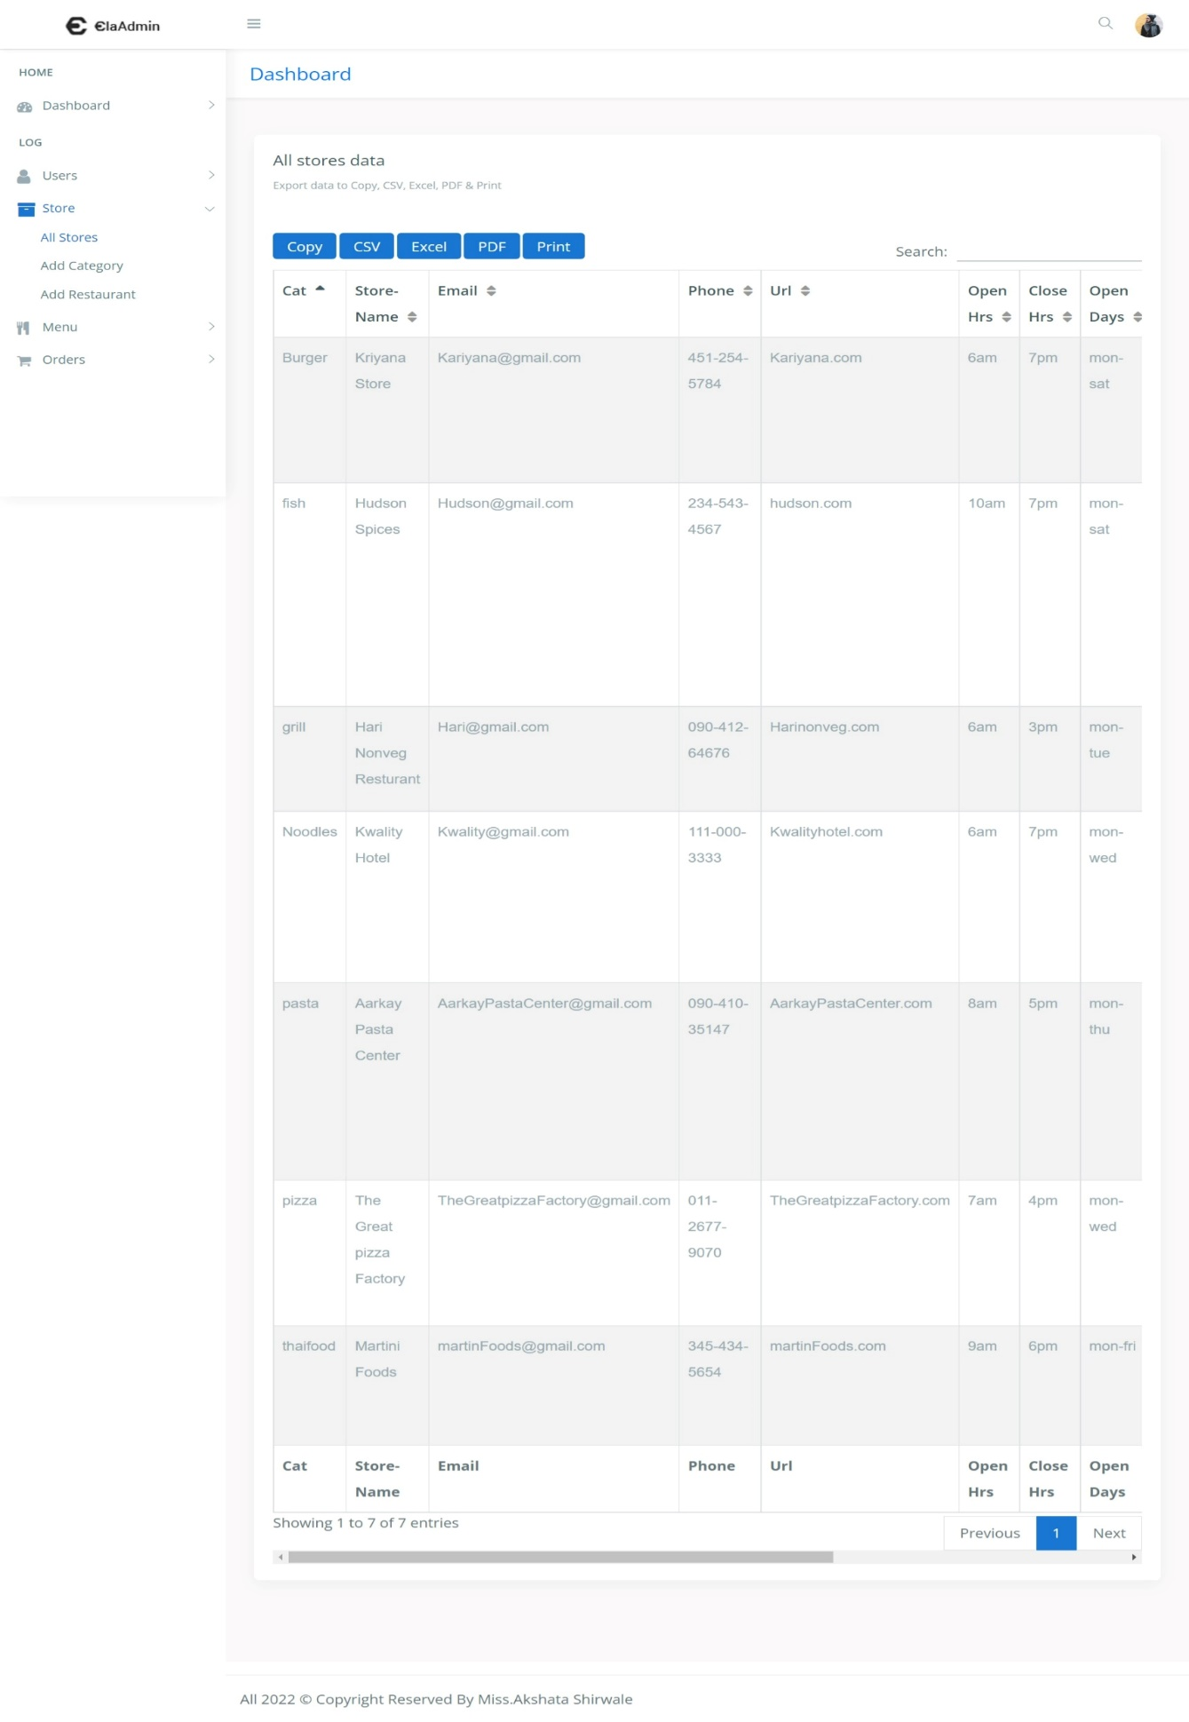

**ALL MENU DASHBOARD :-**

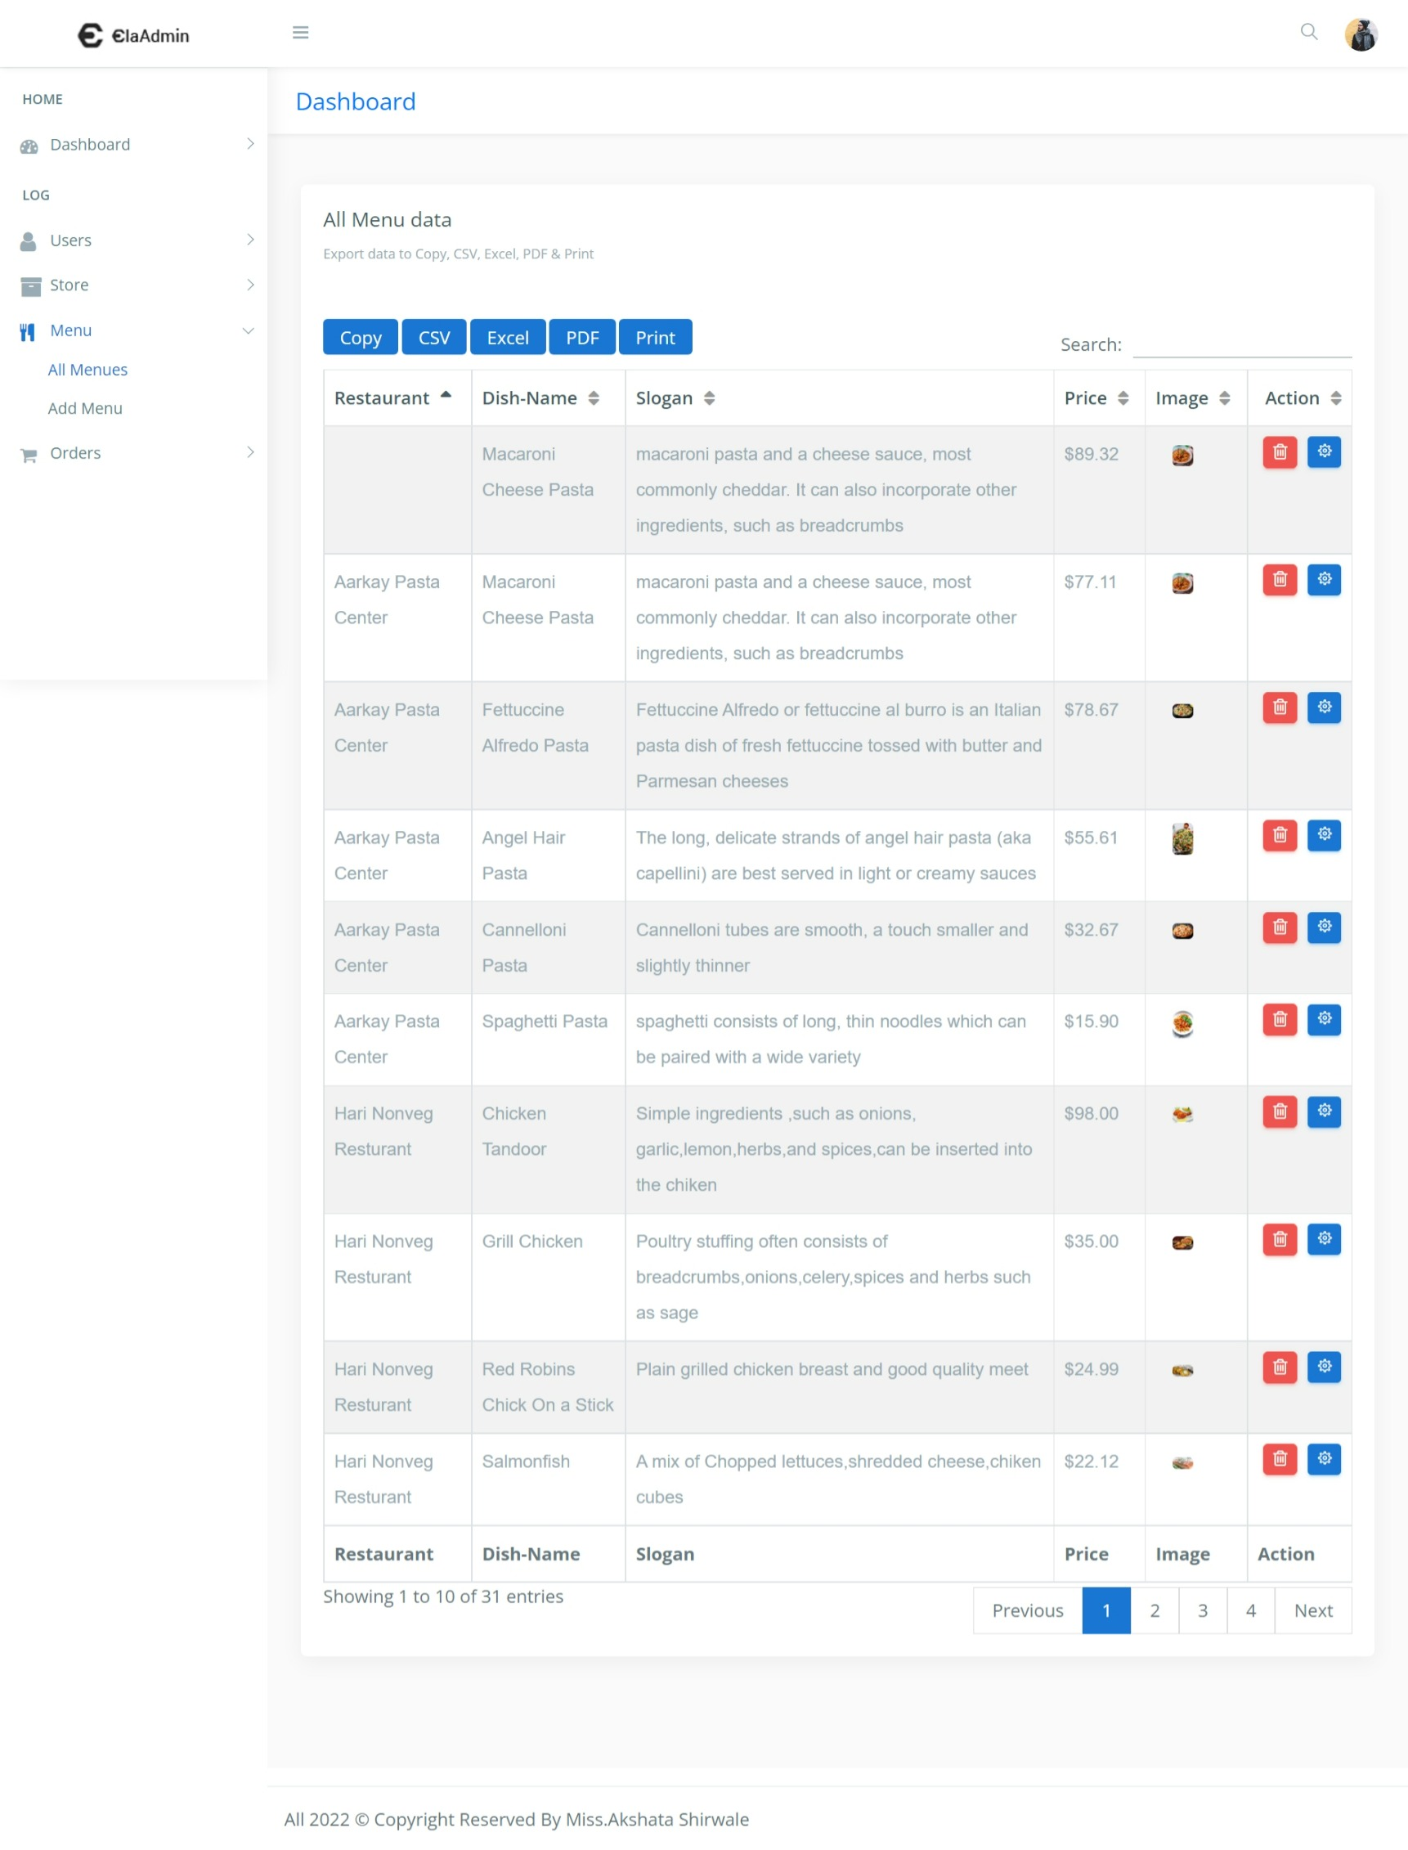

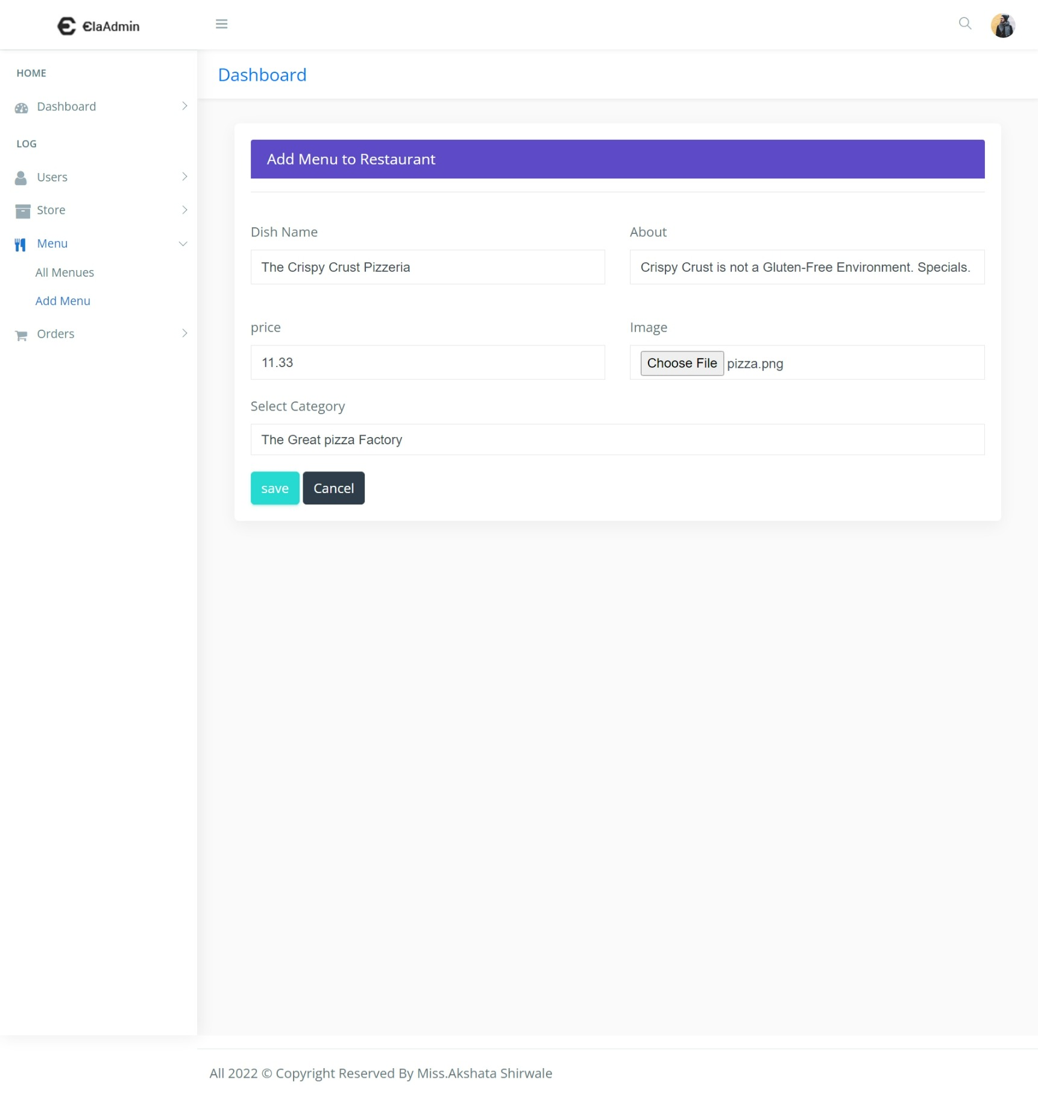**ADD MENU TO THE RESTAURANT :-**

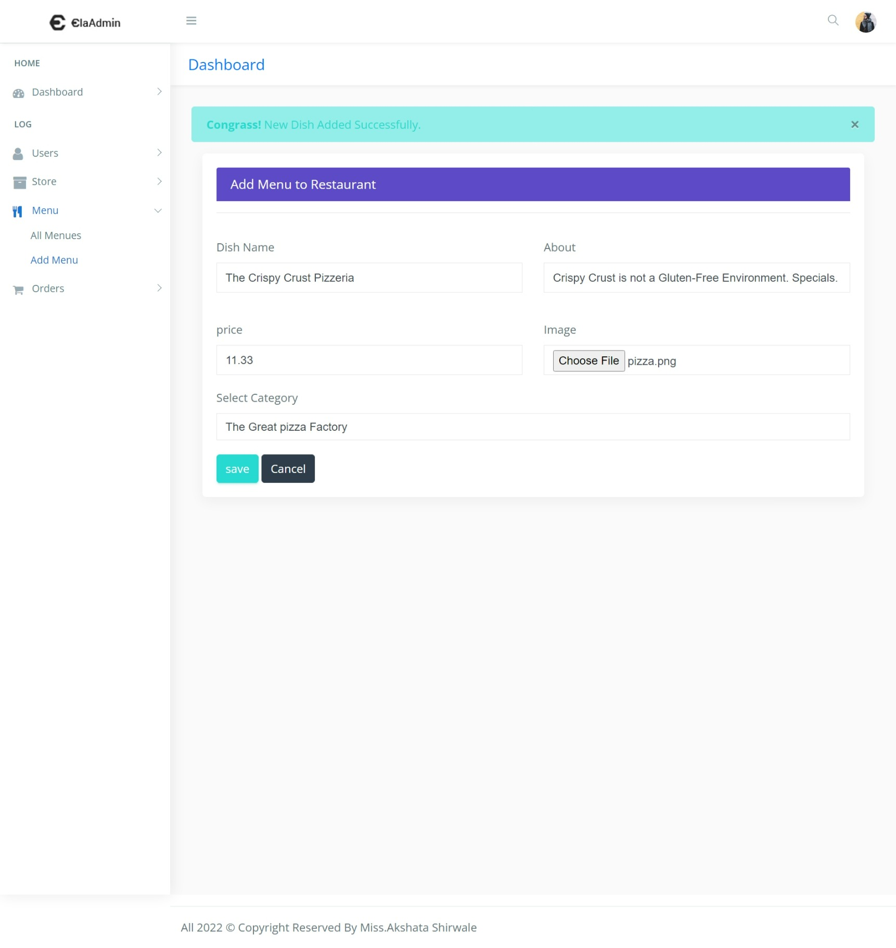**After successfully added the new MENU :-**

**UPDATE THE MENU :-**

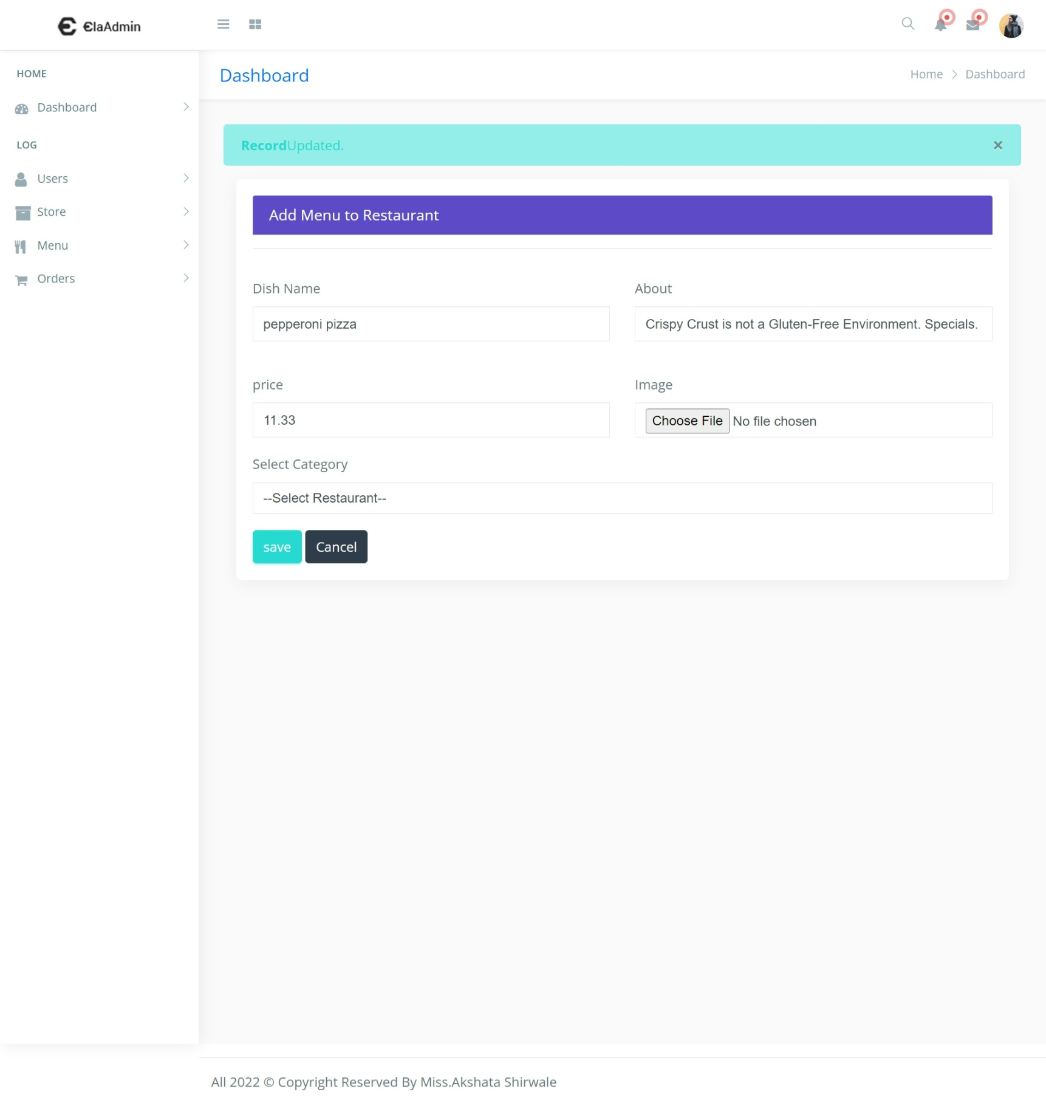**After successfully UPDATED the new MENU :-**

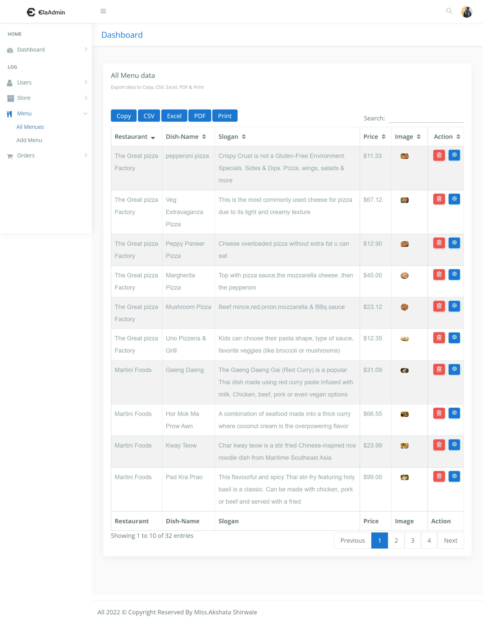**DISPLAY ALL UPDATED AND ADDED RECOREDS ON THE DASHBOARD :-**

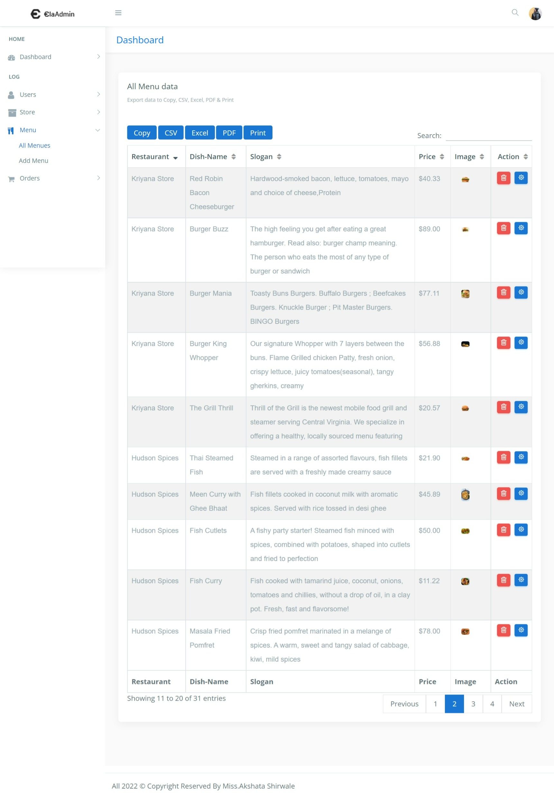**DELETE THE MENU :-**

**SEARCH THE MENU :-**

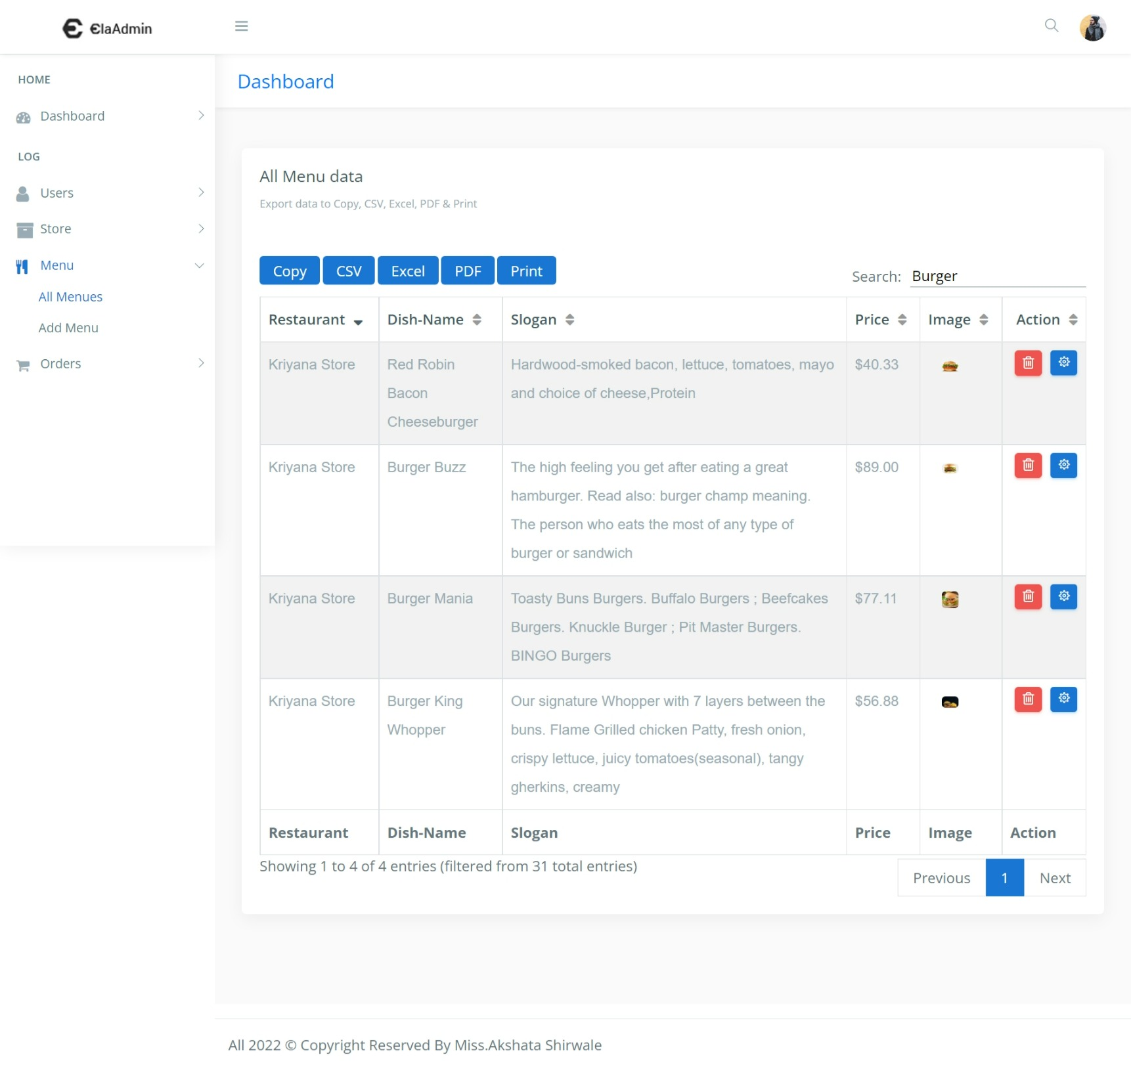

**All order dashboard :-**

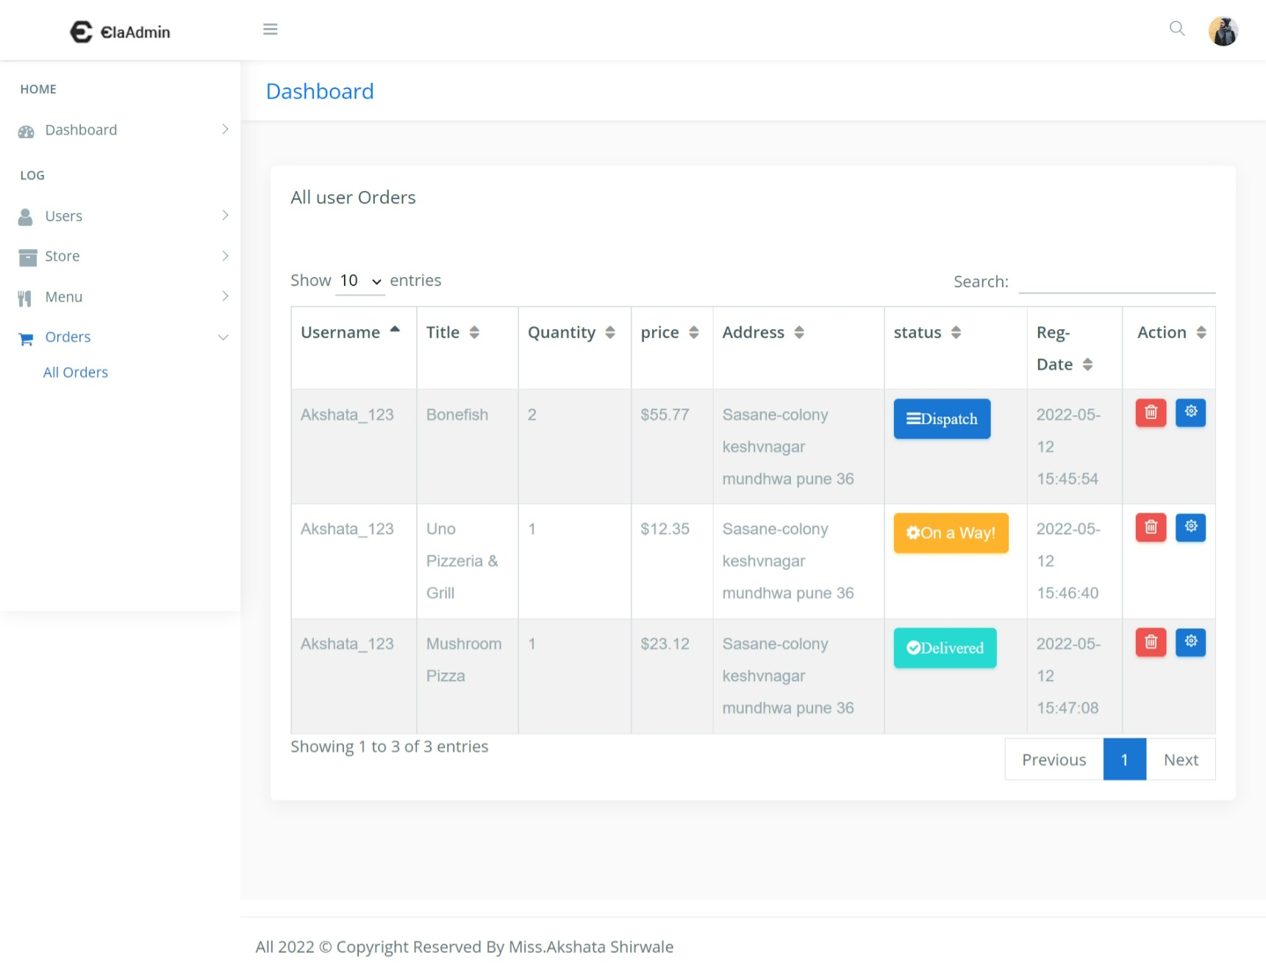

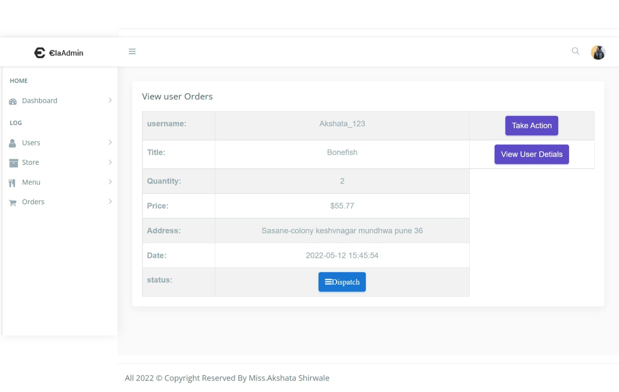**View user details :-**

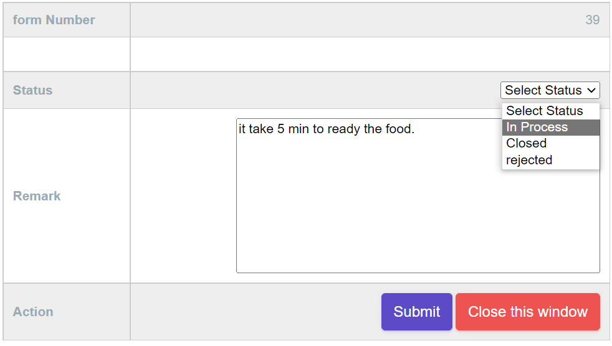**Update the order :-**

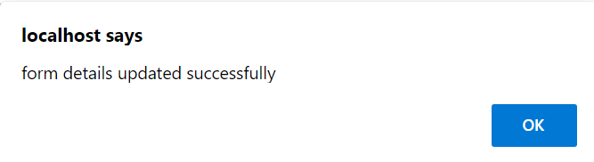**After successfully updated the form :-**

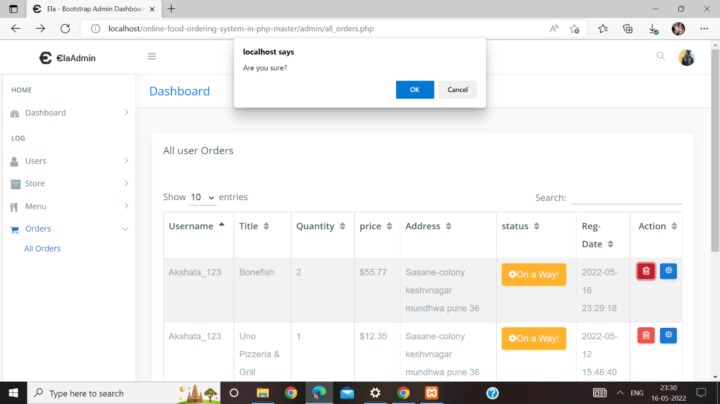**Delete the order :-**

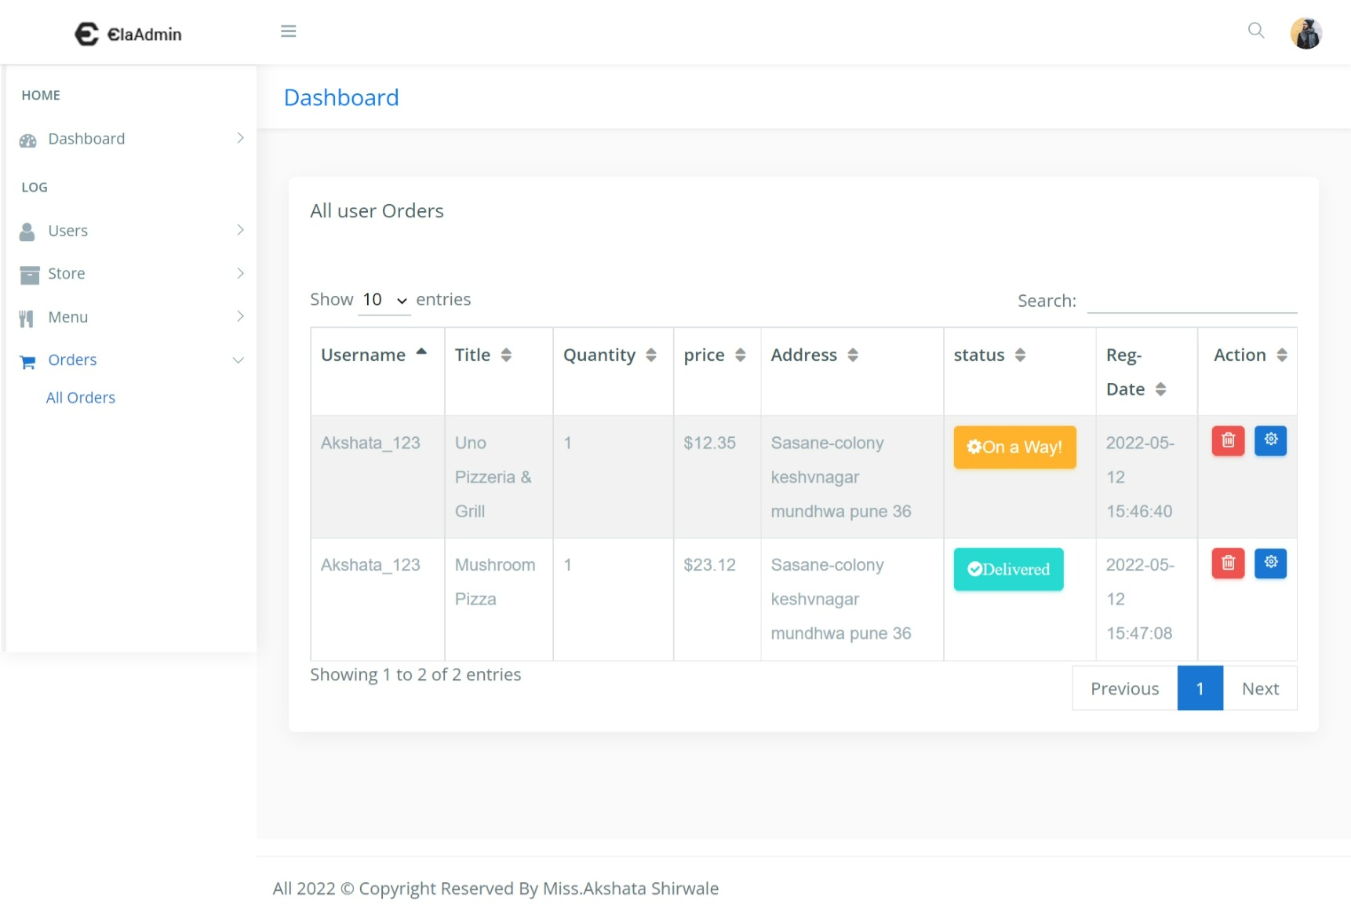**After successfully deleted the order :-**

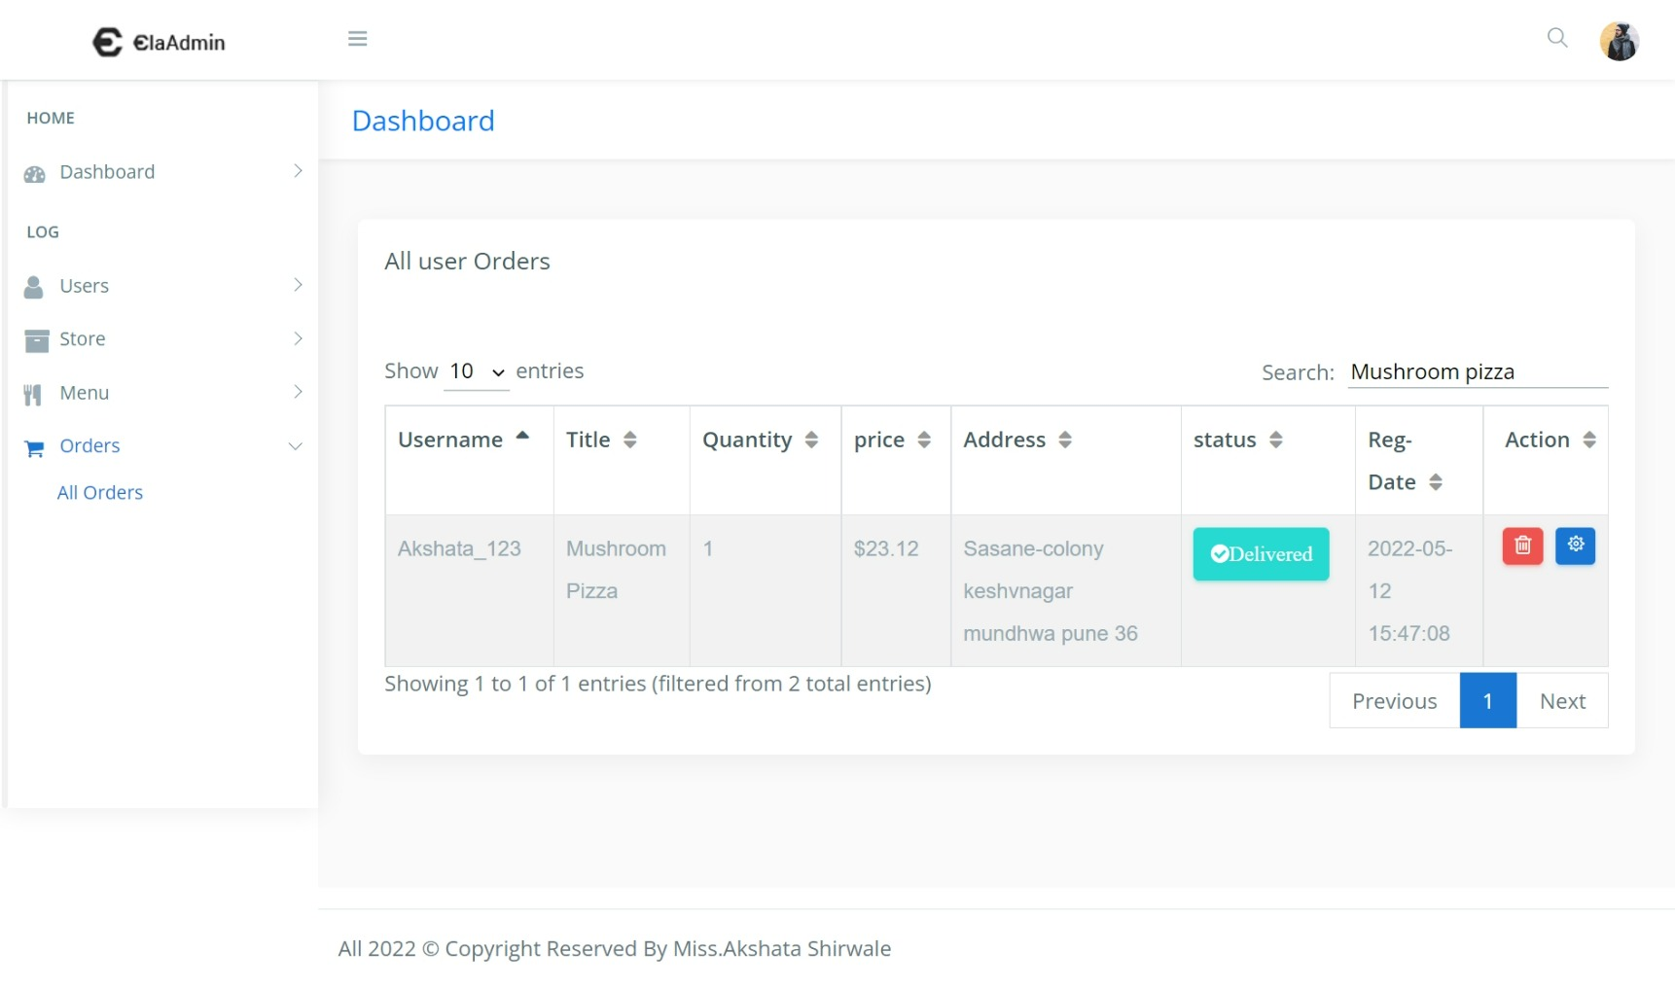**Search the order :-**

**Reports to see all store information :-**

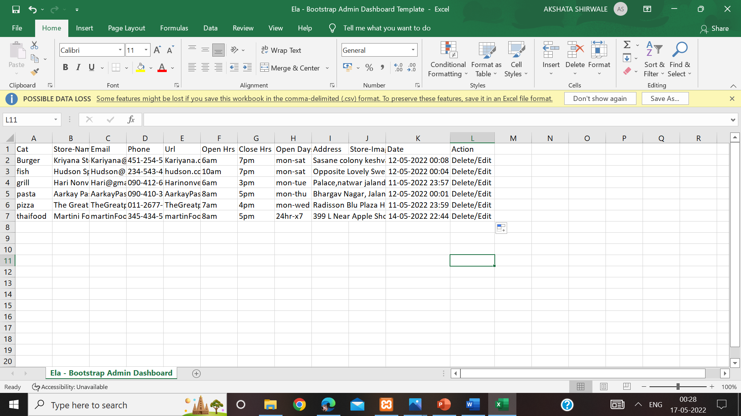**CSV FORMAT :-**

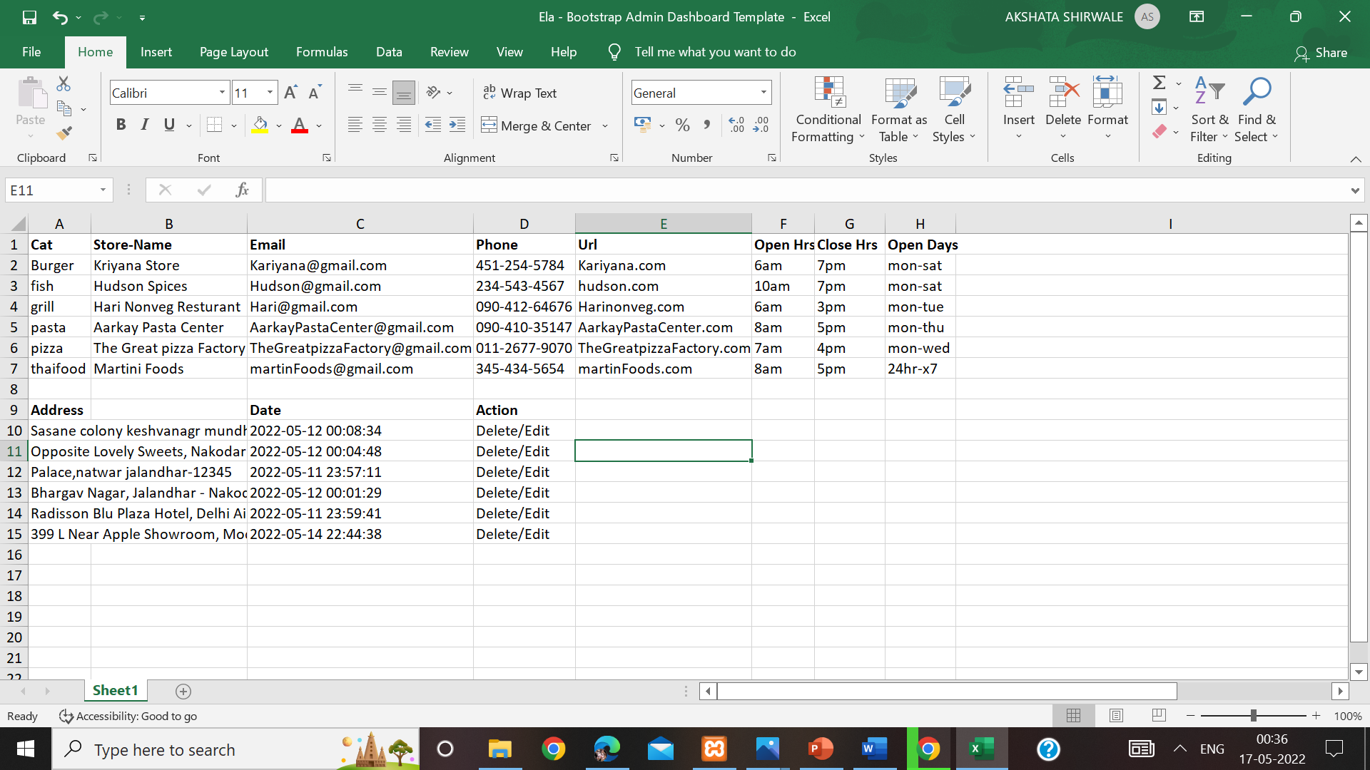**Excel format :-**

**Pdf format :-**

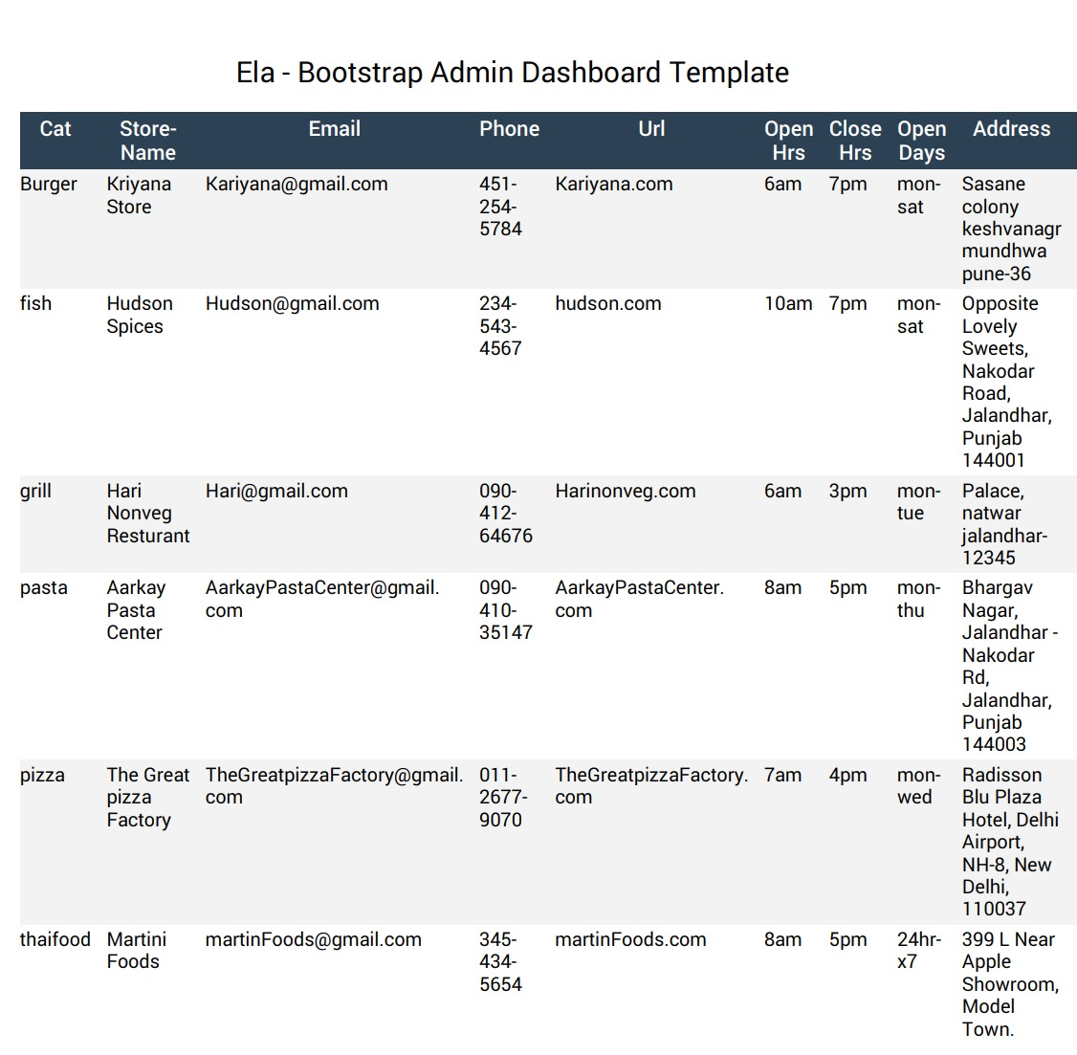

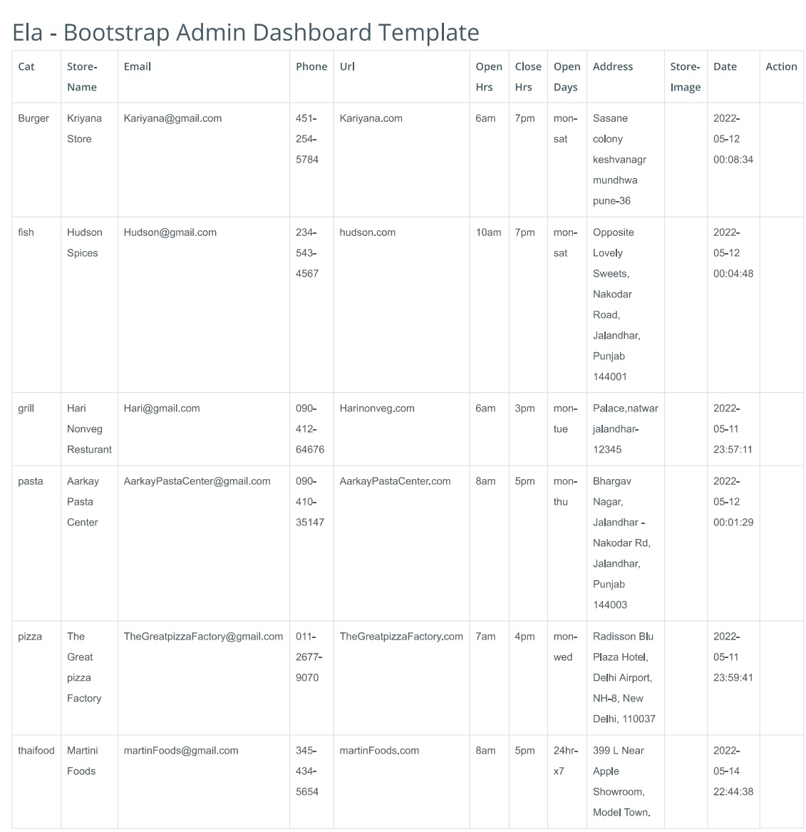**Print format :-**

**Reports tp see all store information :-**

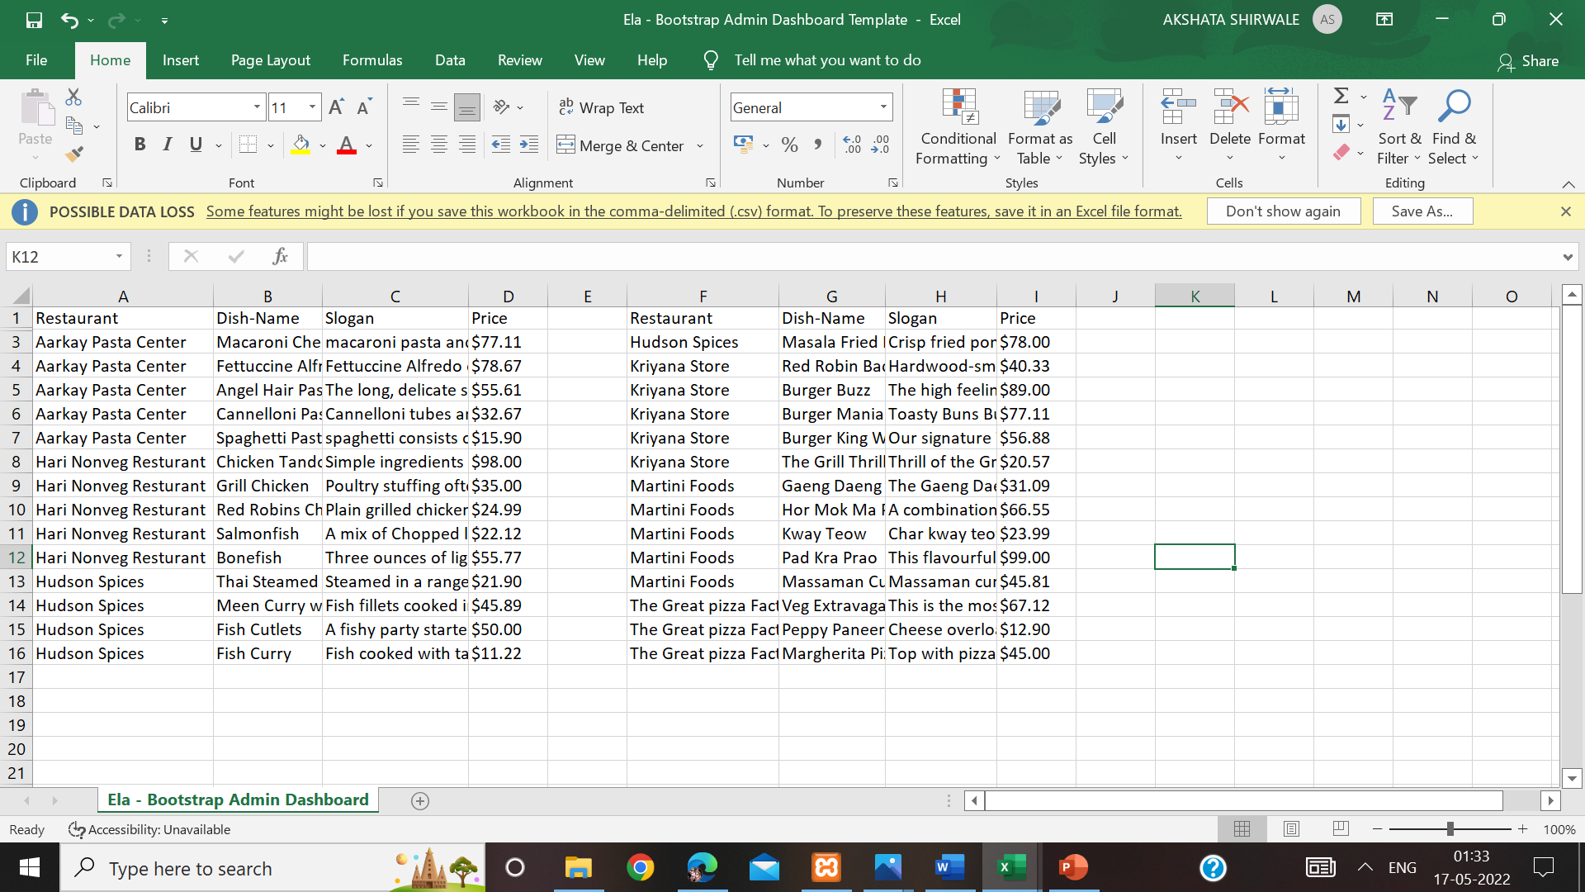**CSV FORMAT :-**

**Excel format :-**

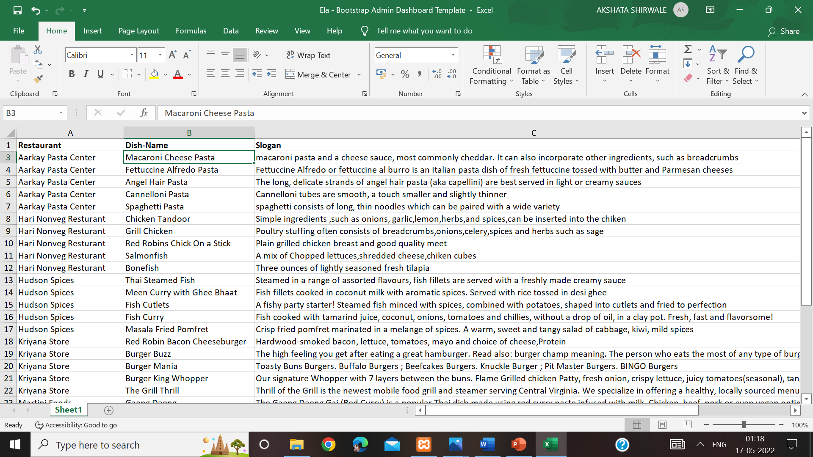

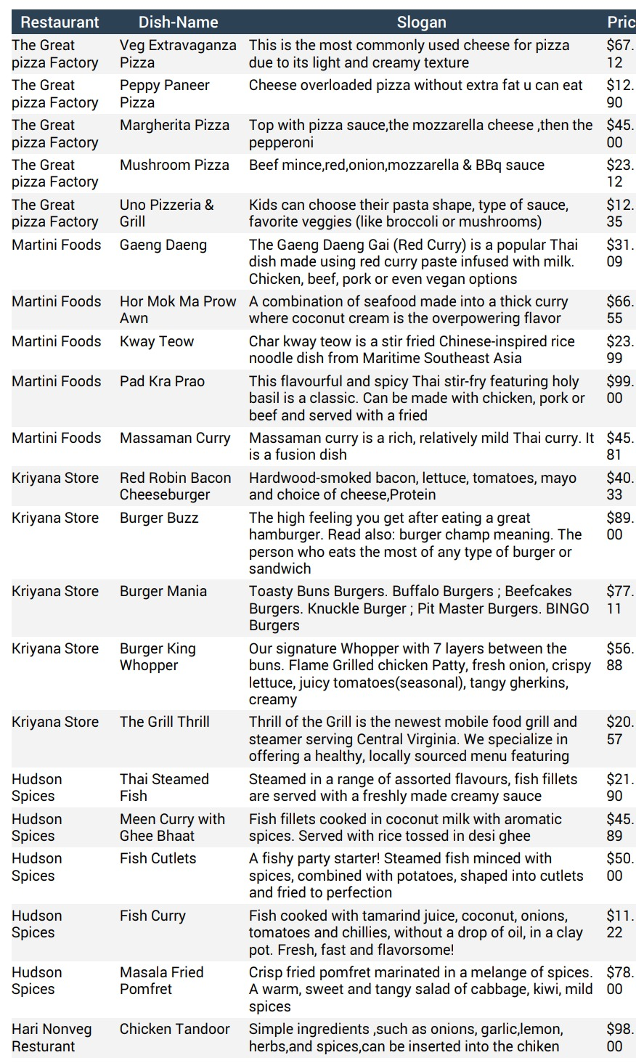**Pdf format :-**

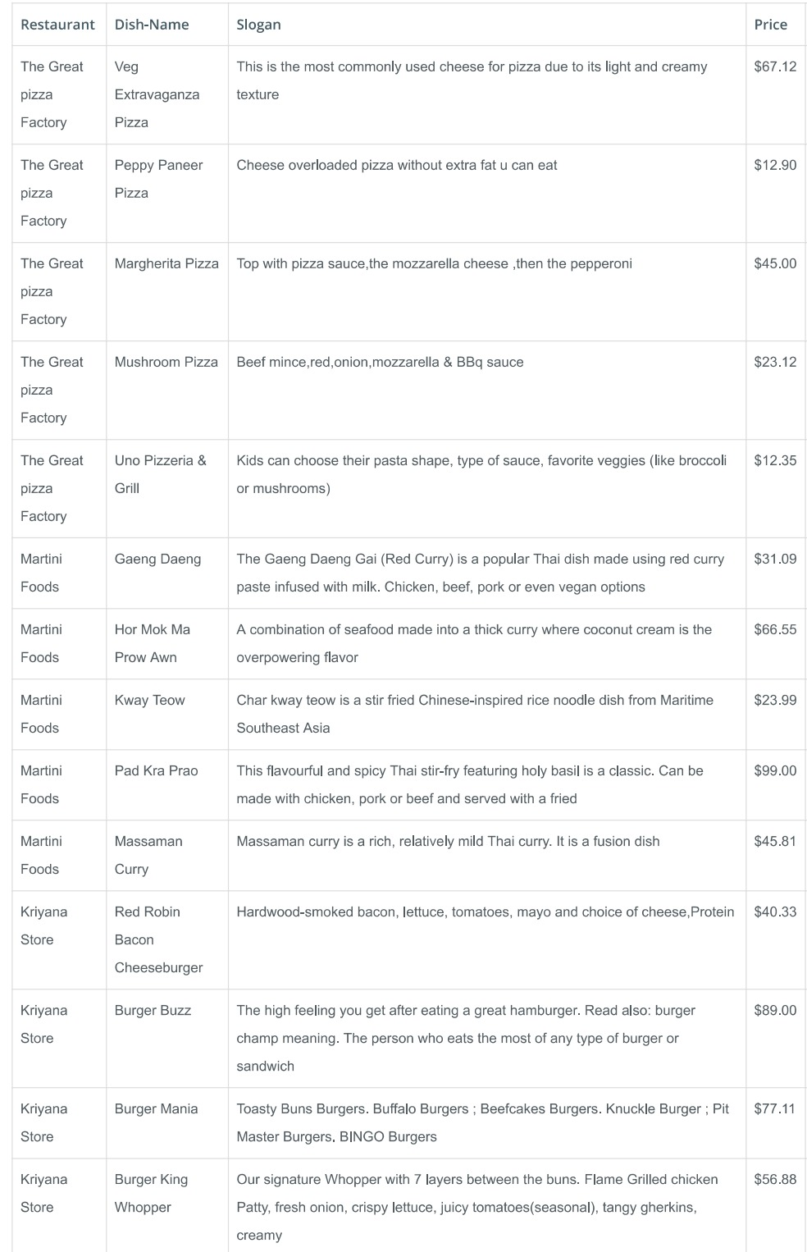**Print format :-LIMITATIONS :-**

**Although I have put my best efforts to make the software flexible, easy to operate but limitations cannot be ruled out even by me. Though the software presents a broad range of options to its users some intricate options could not be covered into it; partly because of logistic and partly due to lack of sophistication. Paucity of time was also major constraint, thus it was not possible to make the software full proof and dynamic. Lack of time also compelled me to ignore some part such as storing old result of the candidate etc. Considerable efforts have made the software easy to operate even for the people not related to the field of computers but it is acknowledged that a layman may find it a bit problematic at the first instance. The user is provided help at each step for his convenience in working with the software.**

**List of limitations :-**

* **This application will only run in Windows Operating System.**
* **This application does not provide automatic recovery and backup feature.**
* **The transactions are executed in off-line mode, hence the invoice payment receipt are not generated right now.**
* **The order is cancelled the cancel receipt of the food is not generated right now.**

**Conclusions :-**

**Our project is only a humble venture to satisfy the needs to manage their project work. Several user friendly coding have also adopted. This package shall prove to be a powerful package in satisfying all the requirements of the school. The objective of software planning is to provide a frame work that enables the manger to make reasonable estimates made within a limited time frame at the beginning of the software project and should be updated regularly as the project progresses.**

* **Paper Work is removed as far as possible.**
* **The information of customer’s customer’s orders, cancellation, payment and refund (if any) are collected, stored and updated efficiently.**
* **Reports of information of customer’s order, payment their menu, are generated quickly.**
* **Daily income information of customer’s is ascertained.**
* **Monthly income information of booked orders of customers is ascertained.**
* **Daily orders and events order’s and information is maintained efficiently.**

**BIBLIOGRAPHY :-**

**References and Bibliography :-**

* **Google for problem solving**
* [**http://www.javaworld.com/javaworld/jw-01- 1998/jw-**](http://www.javaworld.com/javaworld/jw-01-%20%20%201998/jw-) **01-Credentialreview.html**
* **Database Programming with JDBC and Java by O'Reilly**
* **Head First Java 2nd Edition**
* **http://www.jdbc-tutorial.com/**
* **Java and Software Design Concepts by Apress**
* **https://www.tutorialspoint.com/java/**
* **http://www.javatpoint.com/java-tutorial**
* **https://docs.oracle.com/javase/tutorial/**
* **http://www.wampserver.com/en/**
* **http://www.JSP.net/**
* **http://www.tutorialspoint.com/mysql/**
* **httpd.apache.org/docs/2.0/misc/tutorials.html**